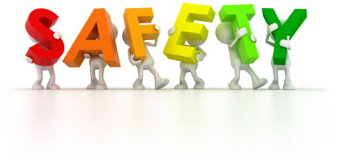

**Safety Pledge:**

**I will, you will, we all will…**

I will… be responsible and follow all traffic and safety procedures of Sycamore Trails Elementary school. Be respectful of the entire Sycamore Trails community. Always be alert. 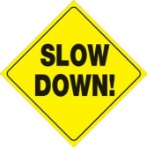

You will… drive slow, stay off your phone, make right turns only, and always pull forward. Stay calm. 

We all will… be good role models for our children and create a safe environment for them to come and go from school. 

We pledge to be SAFE!

Principal: ___________________________________________________

Teacher: ____________________________________________________

Parent/Guardian:_____________________________________________

Student: ____________________________________________________