**The time is always right to do the right**

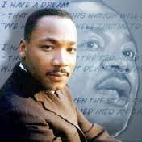

**thing.** ~Dr. Martin Luther King Jr.~