Grade 3 Module 2 Topic B Tips and Suggestions for Modifications
Lesson 6
- Exit Ticket: The goal is for students to figure out how many grams are in a kilogram.
- Problem Set: Students need to know how to decompose Kilograms and grams.
- Homework: Students need to know how to decompose and how to read a scale.
- Concept Development:
  - Part One
    - Skip Part One if you do not have enough beans and rice.
    - Two standard water bottles are equal to 1 kilogram. If you want, pass around 2 water bottles in a bag so students can feel what a kilogram feels like.
  - Part Two:
    - Do a demonstration lesson. Teacher can demonstrate how to decompose a bag of beans. Student can follow along by drawing it on the problem set.
- Supplement Fluency: Have pictures of scales and have student practice reading them. Teacher can show a scale and ask students to read it.
Lesson 7
- Exit Ticket: The goal is for students to be able to read scales with kilogram and grams. They are also supposed to be able to estimate the weight of objects.
- Problem Set: Make sure students are able to complete problem E with understanding
- Homework: Students need to know how to read a scale and how to estimate weight.
- Concept Development:
  - Part One
    - Keep the Concept Development the same. Show students pictures of spring scales in grams and Kilograms.
  - Part Two:
    - If you do not have the weights use the following
      - 1 Kilogram: Put two waters bottles in a bag
      - 1 gram: 1 paperclip
      - 10 grams: 10 paperclips or 2 nickels
      - 100 grams: 20 nickels or 100 paperclips

- Fluency: Decompose 1 kilogram and Gram Counting.
Lesson 8
- Exit Ticket: The goal is for student to perform addition and subtraction on one step word problems.
- Problem Set: Make sure students are able to complete Problems 1 and 2
- Homework: Students need to know solve adding and subtracting word problems.
- Concept Development:
  - Problem 1
    - If you do not have beans, rice, or popcorn, use other objects that you have in the classroom. Or skip #1

  - Problem 2-4
    - Adjust as you see necessary.
  - There are many word problems the teacher is to project for the students. Be prepared and have questions written out beforehand (either have in a power point, or be able to display them under a document camera.) It would be beneficial for the students to have their own copy of the word problems with space between the problems so they could follow along.
  - You will find a sample of Student’s Notes Page at the end of this document. Please read the concept development so that you are using the same vocabulary and suggested strategies. You do NOT have to do all the questions from the Concept Development. Pick questions based on your student population.
- Reminder: RDW is done with EVERY word problem whether is it found in the Problem Set, Exit Ticket or Homework. Remember to model to RDW process during the Concept Development and remind students to use RDW for all of the problems.

Lesson 9
- Exit Ticket: The goal is for students to be able to know how many 100 milliliters are in a Liter and how many 10 milliliters are in a Liter.
- Problem Set: Make sure students are able to complete problem E with understanding
- Homework: The homework is word problems where students are preforming arithmetic to measurement problems. This is a review from Lesson 8. If you send this home for homework, be sure to note to parents to refer to Lesson 8. Remember, you do not have to assign homework.
- Concept Development:
  - Part One
    - Teacher demonstration
  - Part Two:
    - This is a teacher demonstration lesson. This part directly aligns with the Problem Set and Exit Ticket and can’t be skipped. You will have to demonstrate and also walk student how to fill in the Problem Set. This will take time. Have answers already written out for Problem Set so students can quickly copy as you demonstrate.
    - Do the Math Chat Video from Zearn.org instead of teacher demonstration.

Lesson 10
- Exit Ticket: The goal is for students to be able to read a vertical number line and to apply arithmetic to numbers on the vertical number line.
- Problem Set: Problems 2, 3 and 4e match the Exit Ticket
- Homework: Students have to read a vertical number line on objects and a plain number line. They also have to solve real life word problems.
- Concept Development:
  - Part One
    - This could be done as teacher demonstration for sake of time and materials.
    - Do the Math Chat Video from Zearn.org instead of teacher demonstration.
  - Part Two:
    - This could be done as teacher demonstration for sake of time and materials.
    - Do the Math Chat Video from Zearn.org instead of teacher demonstration.
  - NOTE: The goal is for students to be able to read a vertical number line. Be sure to provide multiple exposures to how to read a number line. This is a rare lesson that we would suggest the teacher using the Problem Set questions 2-4 as a teaching tool and skipping the Concept Development if the teacher does not have the supplies to correctly instruct this lesson.
Lesson 11
- Exit Ticket: Students have to solve word problems involving adding, dividing and multiplying measurements with same unit to find the answers.
- Problem Set: Students use arithmetic to solve multi-step word problems.
- Homework: Homework matches Problem Set and Exit Ticket.
- Concept Development:
  - There are many word problems the teacher is to project for the students. Be prepared and have questions written out beforehand (either have in a power point, or be able to display them under a document camera.) It would be beneficial for the students to have their own copy of the word problems with space between the problems so they could follow along.
  - Below you will find a sample of Student’s Notes Page. Please read the concept development so that you are using the same vocabulary and suggested strategies. You do NOT have to do ALL the questions from the Concept Development. Pick questions based on your student population.
- Reminder: RDW is done with EVERY word problem whether is it found in the Problem Set, Exit Ticket or Homework. Remember to model to RDW process during the Concept Development and remind students to use RDW for all of the problems.

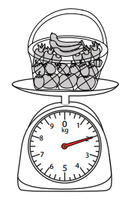 | 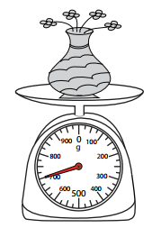 | 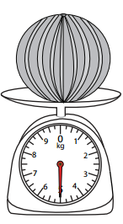 | 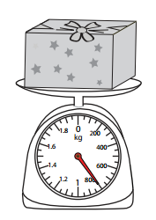
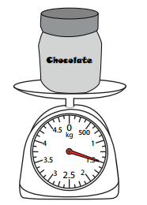 | 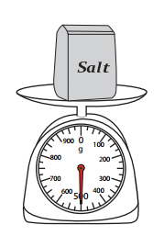 | 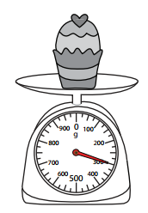 | 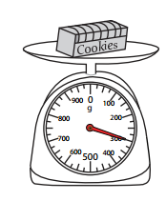
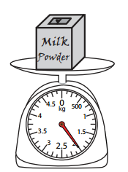 | 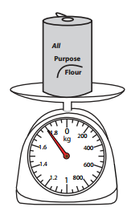 | 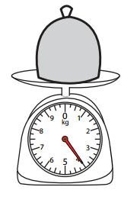 | 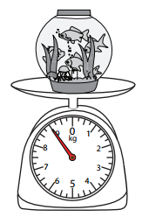
Grade 3 Module 2 Lesson 7 Extra Scale Reading

Grade 3 Module 2 Lesson 8 Student Notes Page
Problem 2

- Lindsey wants to ride the roller coaster. The minimum weigh to ride is 32 kilograms. She weighs 14 kilograms less than required. How many kilograms does Lindsey weigh?

- Ms. Casallas buys new cabinet for the classroom. It comes in a box that weighs 42 kilograms. Ms. Casallas unpacks pieces that total 16 kilograms. How much does the box weigh now?

- Mr. Flores weighs 73 kilograms. After exercising every day for six hours, he loses the weight. Now he weighs 67 kilograms. How much weight did he lose?

Problem 3

a) See Concept Development in Teacher Materials

b) Jerry bought 3 bags of groceries. Each bag weighs 4 kilograms. How many kilograms do Jerry’s grocery bags weigh in all?

c) A dictionary weighs 3 kilograms. How many kilograms do 9 dictionaries weigh?

Problem 4
a) Eight chairs weigh 24 kilograms. What is the weight of 1 chair?

b) Thirty-six kilograms of apples are equally distributed into 4 crates. What is the weight of each crate?

c) A tricycle weighs 8 kilograms. The delivery truck is almost full but can hold 40 kilograms more. How many more tricycles can the truck hold?

Grade 3 Module 2 Lesson 11 Student Notes Page
Problem 1

- A pet mouse weighs 34 grams. A pet hamster weighs 126 more grams. How much does the pet hamster weigh?

- Judith squeezes 140 milliliters of lemon juice to make 1 liter of lemonade. How many milliliters of juice are in 2 Liters of lemonade?

- Robert’s crate of tools weighs 12 kilograms. He takes his power tolls out. Now the crate weighs 4 Kilograms. How many kilograms do the power tools weigh?

Problem 2

- A pitcher of shaved ice needs 5 milliliters of food coloring to turn red. How many milliliters of food coloring are needed to make 9 pitchers of shaved red ice red?

- Alyssa Drinks 3 liters of water every day. How many liters will she drink in 8 days?

- There are 4 grams of almonds in each bag of mixed nuts. How many grams of almonds are in 7 bags?

Problem 3

- At the pet store there are 36 liters of water in a tank. Each fish bowl holds 4 liters. How many fish bowls can the shopkeeper fill using the water in the tank?

- Every day the school garden gets watered with 7 liters of water. How many days pass until the garden has been watered with 49 liters?

- A bin at the grocery store holds 9 kilograms of walnuts. The total value of 9 kilogram of walnuts is $36. How much does 1 kilogram of walnuts cost?

Problems to do in Pairs

- Together an orange and a mango weigh 637 grams. The orange weighs 385 grams. What is the weight of the mango?

- A rabbit weighs 892 grams. A guinea pig weighs 736 grams. How much more does the rabbit weigh than the guinea pig?

- Twenty-four kilograms of pineapple are needed to make 4 identical fruit platters. How many kilograms of pineapple are required to make 1 fruit platter?

- The capacity of a pitcher is 3 liters. What is the capacity of 9 liters?

- Jack uses a beaker to measure 250 milliliters of water. Angie measure doubles that amount. How many milliliters of water does Angie measure?

