Eureka Math Tips for Parents
Grade 3 • Module 4

Multiplication and Area  In this 20-day module, students explore area as an attribute of two-dimensional figures and relate it to their prior work with multiplication. Students will build understanding that a 2x6, 1x12, and 3x4 rectangle each have the same area, and will learn how to calculate the area of a floor plan of their own design. | Grade Level Standards  3.MD.5,3.MD.6, 3.MD.7  Student Report Card  Understands area and relates area to multiplication and addition.

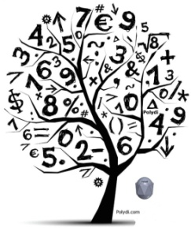
Key Vocabulary
- Area – the amount of two dimensional space inside a bounded region
- Area model - a model for multiplication that relates rectangular arrays to area
- Square unit – a unit of area (could be square centimeters, inches, feet, or meters)
- Tile (as a verb) – to cover a region without gaps or overlaps
- Unit Square – whatever the length unit (e.g. centimeters, inches), a unit square is a 1 unit by 1 unit square of that length
- Whole Number – an integer number without fractions

How you can help at home:
- Continue to review multiplication and division math facts with your student
- Practice drawing simple two dimensional rectangular shapes and calculating the area using multiplication
- Measure the perimeter and area of the rooms in your home to determine which rooms are the smallest and largest
- Use grid paper to make rectangles with the same perimeters. Determine the area of each rectangle.
Models and Representations

This flow chart shows how 3rd grade students start working with arrays in earlier Modules. In Module 4, they become comfortable with the connection between rectangular arrays to the area of a two-dimensional region.

Through exploration students will work with square units (square centimeters and square inches) to create rectangular arrays with the same area, but different side lengths. Students will begin to relate total area with multiplication of side lengths. |  | Students will apply their understanding of area to find missing lengths of a figure.  32 ÷ 4 = w  32 ÷ 4 = 8  w = 8
Toward the end of the module, students will learn how to calculate the area of irregular shapes by looking at the area of the rectangles within the shape. Students can use multiple strategies to find the unknown area.
Break Apart Strategy  Area A + Area B = Area of Figure  (2 x 4) + (2 x 2) = 8 + 4 = 12 sq. units | Subtract to Find Area  Area of Figure – Area B = Area A  (6 x 6) – (4 x 2) = 36 – 8= 28 sq.cm

