Math Journal

Grade 3 Module 7

Application
Problems

Application Problems – Grade 3 - Module 7

Lesson 4:

The third-graders raised $437 in a fundraiser. The fourth-graders raised $68 less than the third-graders. How much money did the two grade levels raise altogether?
Application Problems – Grade 3 - Module 7

Lesson 6:

Frankie says that all squares are rectangles, but not all rectangles are squares. Do you agree with this statement? Why or why not? Draw diagrams to support your statement.

Application Problems – Grade 3 - Module 7

Lesson 9:

Name at least two attributes that a trapezoid, a square, and a parallelogram all have in common. Draw a diagram to support your ideas.

Application Problems – Grade 3 - Module 7

Lesson 10:
Trista uses all seven of her tangram pieces to make a square as shown. One side of the large square is 4 inches long. What is the total area of the two large triangles? Explain your answer.
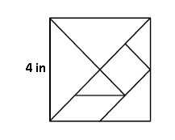
Application Problems – Grade 3 – Module 7

Lesson 12:
Angela measures the sides of a square napkin with her ruler. Each side measures 6 inches. What is the perimeter of the napkin?

Application Problems – Grade 3 - Module 7

Lesson 13:
Materials: (S) 3" × 5" index card, ruler

Use your index card to answer the questions.

- What is the perimeter of your index card in inches?

- Place the short end of your index card next to the short end of your partner’s index card. Make a prediction: What do you think the perimeter is of the new shape you made?

- Find the perimeter of the new shape. Was your prediction right? Why or why not?

Application Problems – Grade 3 - Module 7

Lesson 14:

A rectangular sheep pen measures 5 meters long and 9 meters wide. The perimeter of the cow pen is double the perimeter of the sheep pen. What is the perimeter of the cow pen?

Application Problems – Grade 3 - Module 7

Lesson 15:

Clara and Pedro each use four 3-inch by 5-inch cards to make the rectangles below. Whose rectangle has a greater perimeter?

Application Problems – Grade 3 - Module 7

Lesson 17:

Gil places two regular hexagons side by side as shown to make a new shape. Each side measures 6 centimeters. Find the perimeter of his new shape.

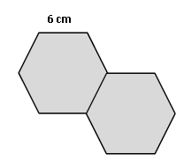

Application Problems – Grade 3 - Module 7

Lesson 18:

Rita says that since 15 is larger than 12, she can draw more arrays to show 15 than she can to show 12. Is she correct? Model to solve.

Application Problems – Grade 3 - Module 7

Lesson 19:

Marci says, “If a rectangle has a bigger area than another rectangle, it must have a larger perimeter.” Do you agree or disagree? Show an example to prove your thinking.

Application Problems – Grade 3 - Module 7

Lesson 20:

Molly builds a rectangular playpen for her pet rabbit. The playpen has an area of 15 square yards.

- Estimate to draw and label as many possibilities as you can for the playpen.

- Find the perimeters of the rectangles in Part (a).

- What other information do you need in order to recreate Molly’s playpen?

Application Problems – Grade 3 - Module 7

Lesson 21:

Mrs. Zeck will use 14 feet of tape to mark a rectangle on the gym wall. Draw several rectangles that Mrs. Zeck could make with her tape. Label the side lengths of each rectangle.

Application Problems – Grade 3 - Module 7

Lesson 26:

Drew makes rectangular shoes for his robot. Each shoe has whole number side lengths and an area of 7 square centimeters. What is the total perimeter of both shoes?
Is there more than one answer? Why or why not?

Application Problems – Grade 3 - Module 7

Lesson 31:

Mara draws a 6 inch by 8 inch rectangle. She shades one-half of the rectangle. What is the area of the shaded part of Mara’s rectangle?

Application Problems – Grade 3 - Module 7

Lesson 32:

Hannah traces square-inch tiles to draw 3 larger squares. She draws the 3 large squares side by side to make a rectangle. She shades one-half of each larger square, as shown.

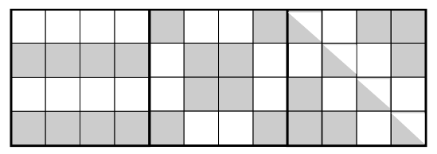

- Do you agree that all 3 squares are one-half shaded? Explain your answer.

- What is the area of the rectangle?

- What is the total area of the shaded space?

Application Problems – Grade 3 - Module 7

Lesson 34:

There are 9 bicycles and some tricycles at the repair shop. There are 42 total wheels on all the bicycles and tricycles. How many tricycles are in the shop?

