Eureka Math Tips for Parents
Grade 6 • Module 6

Statistics and Probability  In this module, students will move from simply representing data into analysis of data. Students will begin to think and reason statistically, first by recognizing a statistical question as one that can be answered by collecting data. Students will learn that the data collected to answer a statistical question has a distribution that is often summarized in terms of center, variability, and shape. Students will also see and represent data distributions using dot plots, histograms, and box plots. | Grade Level Standards  6.SP.1, 6.SP.2, 6.SP.3, 6.SP.4,6.SP.5  Student Report Card  Understands statistical variability and distributions.

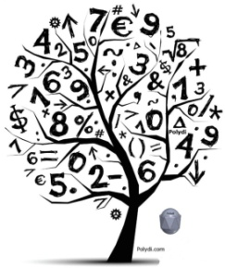
Key Vocabulary
- Median - The middle number in a sorted list of numbers. To find the Median, place the numbers you are given in value order and find the middle number.
- Mean – The average of a set of numbers. To find the Mean, add up all the numbers and divide by how many numbers there are.
- Dot Plot - A graphical display of data using dots.
- Histogram - A graphical display where the data is grouped into ranges (such as "40 to 49", "50 to 59", etc), and then plotted as bars.
- Box Plot - A diagram using a number line to show the distribution of a set of data. The diagram displays the median, quartiles and the minimum and maximum values of data.
- Variability – Occurs when the observations in the data set are not he same.
- Deviations from the Mean – Difference calculated by subtracting the mean from a value in the data set.
- Mean Absolute Deviation (MAD) – The average of the absolute value of the deviations from the mean. (Lessons 9-11)
- Interquartile Range (IQR) – a measure of variability for data that is skewed. It is the difference between the upper quartile and lower quartile of a data set and describes how spread out the middle 50% of the data is.

How you can help at home:
- Every day, ask your child what they learned in school and ask them to show you an example.
- Ask your child to create a data set that represents a symmetrical distribution. One possible solution is below: Symmetrical Data Set: {-2,-2,-1,0,1,2,2)
- Ask your child to explain the measures of center for each graph on the back of the newsletter and have them explain how they determined the centers.
Models and Representations

Symmetrical Data | Skewed Data
Dot Plot | Frequency Table
Box Plot | Histogram

