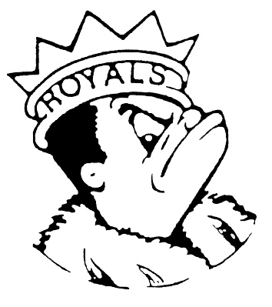***MONDAY***

***November 6, 2023***

***Morning Announcements***

* Today is Cheese, Pepperoni OR Buffalo Chicken Pizza.
* Boys’ Basketball tryouts begin TODAY. All levels will be right after school in the Main Gym. Sign up on the athletic website in order to participate.
* Threadworks will be meeting in B113 TODAY.
* Math Honors Society will have a meeting Wednesday morning at 7am in B203 on November 8th.
* Best Buddies will be meeting TODAY in D69 at 3:15pm.

***Royal Congratulations***

* Congratulations to The Royal Speech Team on taking 2nd place at Round Lake High School this weekend. We had a great start to our season with 4 tournament champions and a handful of other awards. See the Royal Congratulations for all of the winners!

Tournament Champion in Original Oratory - Aiden Weeks

Tournament Champion in Original Comedy - Elliot McGowan

Tournament Champions in Dramatic Duet Acting - Leesa Starin and Jake Boucher-Merlo

Tournament Champion in Informative Speaking - Dipper Green

2nd place in Impromptu Speaking - Abby Walker and Aiden Weeks (tie)

2nd place in Humorous Duet Acting - Jake Boucher-Merlo and LJ Roller, and Elliot McGowan and Fatima Esteban (tie)

2nd place in Informative Speaking - Atziry Serna

2nd place in Special Occasion Speaking - Elliot McGowan

2nd place in Dramatic Duet Acting - Fatima Esteban and Sophia Adkins-Baturin

2nd place in Poetry Reading - Leesa Starin

3rd place in Poetry Reading - Jake Boucher-Merlo

3rd place in Humorous Duet Acting - Lucy Akemann and Sophia Adkins-Baturin

3rd place in Dramatic Interpretation - Nadia Schultz

3rd place in Humorous Interpretation - Quinn Dadabo

3rd place in Impromptu Speaking - Quinn Dadabo

4th place in Prose Reading - Joslyn Cole

4th place in Extemporaneous Speaking - Lara Amaro

4th place in Dramatic Duet Acting - LJ Roller and Lucy Akemann

5th place in Poetry Reading - Jade Caballero-Flores

5th place in Prose Reading - Maria Vazquez

**And Remember Royals,**

**LIVE, LOVE LARKIN!**