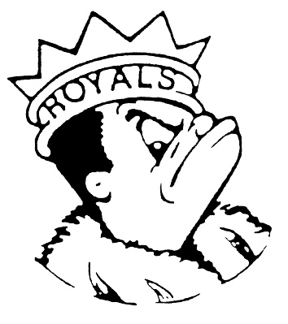***MONDAY***

***October 30, 2023***

***Morning Announcements***

* Today is Philly Cheesesteak OR Tony’s Pizza.
* In Wrestling ... The Final Pre-Season Open Mat will be this Wednesday, from 330-5pm. Meet the wrestling family and see why this program has had 11 straight winning seasons and high-end success in the State and National Level. Season kicks off Next Monday, Nov 6th. On the mat is where it's at ... Let's Wrestle!  Building for Life - Larkin Wrestling
* Attention all girl’s basketball players.  Tryouts are today!!  Freshman and sophomores will be after school from 3:15 until 5:15 and juniors and seniors will be from 5:30-8:00 in the main gym.  Please see Coach Knapp with any questions.
* Anyone who dressed up today and would like to enter the Costume Contest should be sure to submit a photo of themselves today. QR Codes will be posted around the Commons during lunch periods. Don't forget there will be prizes for today and tomorrow's costumes. Winners will be announced Wednesday.
* AFTER SCHOOL HOMEWORK HELP ~ It is a great feeling to be acing your grades. You can get help after school in the library Mondays through Thursdays from 3:00-4:30pm. The 9th Period Royal Academic HUB has tutors to help answer questions; it is also a quiet place to do your work alone. With this extra effort, you can learn more and finish ALL your assignments.

***Royal Congratulations***

**And Remember Royals,**

**LIVE, LOVE LARKIN!**