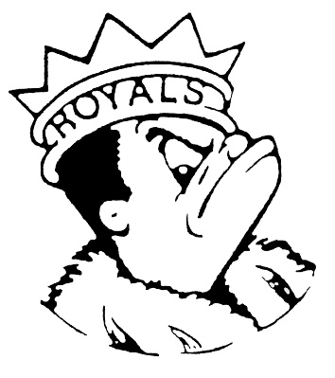***THURSDAY***

***APRIL 18, 2024***

***Morning Announcements***

* Today is Hamburger Or Mac & Cheese w/breadstick.
* Key Club will be meeting TODAY after school from 3-4pm in Room E299.
* Also, there will be a football program information meeting TONIGHT at 6 pm, in the student commons. Players and parents/guardian are encouraged to attend. Any questions or concerns, see coach Ray.
* Key Club will be hosting a card making event for children in the hospital during lunch periods thru Friday, April 19th. Students who come in and make cards can earn up to 1 hour of service for Key Club, NHS and/or Peer Leaders.
* Attention Seniors: Don't forget to pick-up your Permission Slip for Six Flags Grad Nite in the Main Office. Tickets will be available at the Treasurer's Office during Lunch Periods Monday-Wednesday next week. This year's event is Saturday, May 18.
* Can’t believe it’s that time of year. The official Senior Countdown will begin this Friday with A Day – anything but a backpack day. Look for the flyers around the building for the complete list.
* Prom attendees ~ we are taking song requests for prom. Please check your email for the google form.

***Royals Congratulations***

**And Remember Royals,**

**LIVE, LOVE LARKIN!**