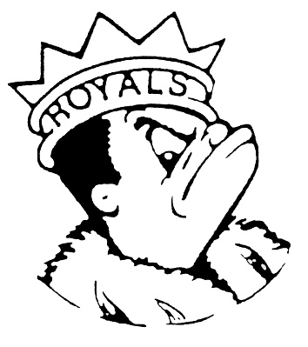***MONDAY***

***November 13, 2023***

***Morning Announcements***

* Today is Chicken Tenders or Grilled Cheese.
* Today is World Kindness Day. Top by the table in Commons during lunch periods to pledge an act of kindness and remember, ‘In a world where you can be anything, be kind.’
* If you are interested in attending the UW-Milwaukee & Wisconsin Lutheran College visit, please check your emails for the google form. The email is the Schoolinks.
* Girl Bowlers after school please go to the front of the school to catch bus 48 for practice at Elgin Lanes.
* Want to know what our Spring Musical is? All week long, the bulletin board outside the Black Box will be giving hints as to what the show is. All will be revealed next week.
* The cast and crew of our fall play, The Tin Woman, would like to thank everyone who came and saw the show this weekend. We ended up raising $106 for Donate Life America, a charity that helps match organ donors with people on transplant waiting lists. Thank you for all of your support.

***Royal Congratulations***

* Congratulations to the Royal Speech Team on taking home first place at the St. Charles East Fall Classic on Saturday. We had 4 Tournament Champions including Leesa Starin and Jake Boucher-Merlo, who are back-to-back tournament champions in Dramatic Duet Acting. See the Royal Congratulations for the full list of winners!
* **Tournament Champion in Dramatic Duet Acting -**Jake Boucher-Merlo and Leesa Starin
* **Tournament Champion in Dramatic Interpretation -**Nadia Schultz
* **Tournament Champion in Humorous Duet Acting -**Fatima Esteban and Elliot McGowan
* **Tournament Champion in Poetry Reading -**Leesa Starin
* **2nd place in Dramatic Duet Acting -**Sophia Adkins-Baturin and Fatima Esteban
* **2nd place in Dramatic Interpretation -**Fatima Esteban
* **2nd place in Humorous Duet Acting -**Sophia Adkins-Baturin and Lucy Akemann
* **3rd place in Extemporaneous Speaking -**Lara Amaro
* **3rd place in Humorous Interpretation -**Quinn Dadabo
* **3rd place in Impromptu Speaking -**Aiden Weeks
* **3rd place in Original Comedy -**Elliot McGowan
* **3rd place in Original Oratory -**Aiden Weeks
* **4th place in Impromptu Speaking -**Abigail Walker
* **4th place in Poetry Reading -**Jake Boucher-Merlo
* **4th place in Prose Reading -**Joslyn Cole
* **4th place in Special Occasion Speaking -**Elliot McGowan
* **5th place in Humorous Interpretation -**Abigail Walker
* **5th place in Oratorical Declamation -**Nadia Schultz
* **6th place in Extemporaneous Speaking -**Joaquin Vega
* **6th place in Impromptu Speaking -**Quinn Dadabo
* **6th place in Original Comedy -**Lucy Akemann
* **7th place in Oratorical Declamation -**Lara Amaro

**And Remember Royals,**

**LIVE, LOVE LARKIN!**