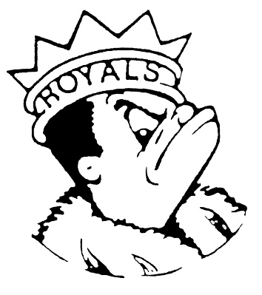***THURSDAY***

***MAY 16, 2024***

***Morning Announcements***

* Today is Italian Meatball Sub w/Marinara Sauce OR Cheese Marinara Pasta s/Bread Stick.
* The official Senior Countdown ~ Today is T for Throwback day. Tomorrow is U for USA Day.
* Attention Seniors Attending Grad Nite at Six Flags Saturday. Please remember to arrive at school by 7:15pm so busses can leave promptly at 7:30pm. We will return to LHS at 4:45am. You can pick-up your Grad Nite Shirt in the Main Office during lunch periods on Friday. Please have your ID with you pick-up the shirt and also to board the bus on Saturday.
* Larkin’s Resident Improv Team, The Larkin Loafs, are having their final show of the year this Friday, May 17th at 7pm in the Black Box. Tickets are $5 on the drama website or at the door. Hope to see you there.

**And Remember Royals,**

**LIVE, LOVE LARKIN!**