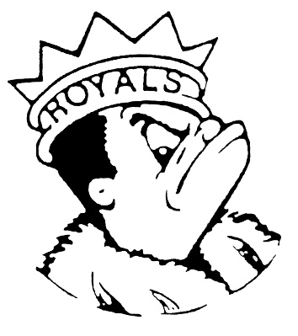***FRIDAY***

***APRIL 19, 2024***

***Morning Announcements***

* Today is Cheese Pizza OR Pepperoni Pizza.
* TODAY is the last day Key Club will be hosting a card making event for children in the hospital during lunch periods. Students who come in and make cards can earn up to 1 hour of service for Key Club, NHS and/or Peer Leaders.
* Attention Seniors: Don't forget to pick-up your Permission Slip for Six Flags Grad Nite in the Main Office. Tickets will be available at the Treasurer's Office during Lunch Periods Monday-Wednesday next week. This year's event is Saturday, May 18.
* The official Senior Countdown ~ Monday is B Day – Barbie vs. Oppenheimer Day.
* Cap and Gown pick up will be Monday and Tuesday of next week.
* TODAY is the last day to purchase a prom ticket. If you would like to purchase a ticket, please stop by the Main Office.
* If you are looking for something to do TONIGHT why not come to see the musical “Six” @ 7pm in the Auditorium. Tickets can be purchased at the door for $5.

***Royals Congratulations***

* In Badminton ... Senior Night Celebration for Out Lady Royal Smashers. Unfortunately, first time in 4 seasons, the Elgin Maroons come on top at our Border War Battle Dual - West Vs East, and defeated our Larkin Royals 6-9

MVP's of the Game: The Class of 2024

**And Remember Royals,**

**LIVE, LOVE LARKIN!**