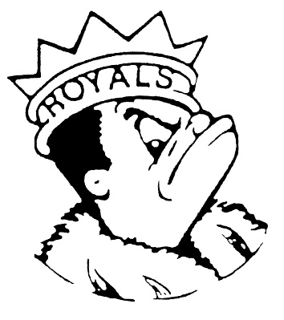***TUESDAY***

***October 31, 2023***

***Morning Announcements***

* Today is Chicken Tenders OR Plant Based Nuggets w/Cheese and a grain.
* Picture Retake Day is tomorrow in the Concession Stand. If you do not take a picture you will not be in the yearbook. Please stop by during your study hall, if you have one, or your lunch hour.

***Royal Congratulations***

**And Remember Royals,**

**LIVE, LOVE LARKIN!**