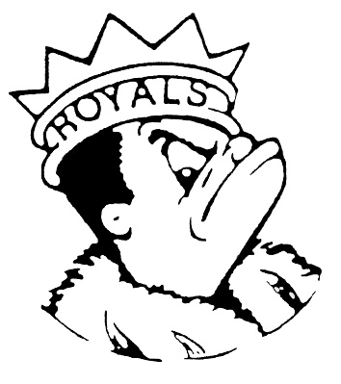 ***THURSDAY***

***May 18, 2023***

***Morning Announcements***

* Today is Which ‘Wich! Hot Ham & Cheese Croissant OR Veg n Cheese Stuffed Sandwich.
* Today is “T” for Twin Day and tomorrow is “U” for USA Day.
* Open swim TODAY from 3-4pm at Larkin Aquatic Center. Come and enjoy.
* Next Monday come celebrate the end of the year with GSA in Room E196. See you there.

***Royal Congratulations***

**And Remember Royals,**

**LIVE, LOVE LARKIN!**