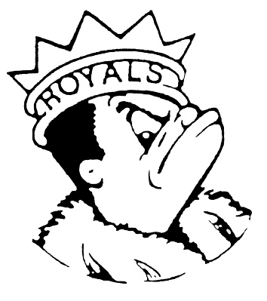***WEDNESDAY***

***September 13, 2023***

***Morning Announcements***

* Today is Hamburger on a Bun OR Grilled Cheese.
* Open Mat is TODAY from 3:35-5pm. We have been averaging 30+ wrestlers each session. Come catch the action and prepare for this upcoming championship season.
* National Honor Society applications are available online until September 15 at 3pm for any junior or senior with a 3.5 cumulative GPA. If you didn't receive a letter, please see Mrs. Carey or Mrs Pavoris ASAP. Also, this is a reminder that the application will close for everyone at 3pm on September 15 and late submissions will not be allowed.
* The Office of Culture and Climate is still looking for pages. Stop by if you are interested.
* Please join Threadworks, formerly Crochet Club for an informational meeting TODAY from 3-4pm in Room B113, a community for all yarn crafters!
* Our Nation Suicide Prevention week fact of the day: You can call or text 988 Lifeline which provides 24/7, confidential support to people in suicidal crisis or mental health-related distress. By calling or texting 988, you'll connect to mental health professionals with the Lifeline network. Don't forget to wear purple for suicide prevention awareness tomorrow!
* French Club meets TODAY after school from 3-4 in Room E196. See Madame Fodor if you have any questions.
* The September 15th football game against South Elgin will be a GOLD OUT for Cal's Angels, a group that raises funds for children's cancer patients. Get your shirt for $10 at lunch Wednesday-Friday this week and support this great cause. Stop by the table, buy a shirt or a Supporting Foot for just $2, and learn what Cal's Angels does for the communities and people they serve.
* Don’t Miss Out On The Next Class Council Meetings To Help Plan Your Homecoming Week!!!
* Class of 2027—Friday, 9/15--Meeting at 7:00AM in F303
* Class of 2026—TODAY--Meeting at 3:15PM in B101
* Class of 2025—Thursday, 9/14--Meeting at 3:15PM in B137
* Class of 2024—Monday, 9/18--Meeting at 3:15PM in B135

***Royal Congratulations***

**And Remember Royals,**

**LIVE, LOVE LARKIN!**