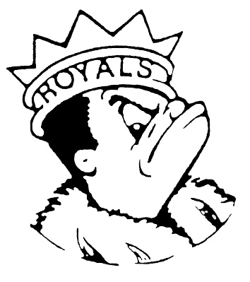 ***MONDAY***

***MAY 6, 2024***

***Morning Announcements***

* Today is Chicken Egg Rolls OR Grilled Cheese.
* The official Senior Countdown ~ Today is L for Look Alike Day (pick someone to twin with) and tomorrow is M for Mix N’ Match (wear clothes that don’t match)
* Attention Seniors! Are you eager to relive some nostalgic memories? Join us for a memorable grad walk experience! On Wednesday, May 22nd, at 10 a.m., we'll stroll down memory lane at Creekside or Washington Elementary. And Thursday, May 23rd, at 10 a.m. at Century Oaks Elementary. To ensure you don't miss out on this unique opportunity to walk down memory lane, please check your email for a Google Form that requires your attention. Remember, to partake, you must have attended that elementary school and dressed in your cap and gown on the day. Let's create unforgettable memories together!

**And Remember Royals,**

**LIVE, LOVE LARKIN!**