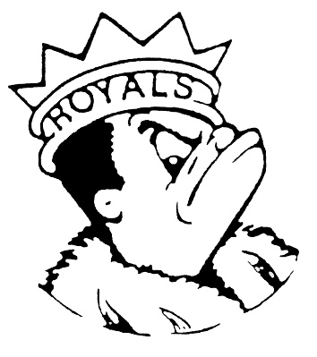***MONDAY***

***APRIL 22, 2024***

***Morning Announcements***

* Today is Cheese Pizza OR Pepperoni Pizza.
* The official Senior Countdown ~ TODAY is B Day – Barbie vs. Oppenheimer Day. Tomorrow is C Day – College/Career Day (dress with your future)
* Cap and Gown pick up will be TODAY and TOMORROW in the Commons. of next week.
* Blue Crew is hosting our first Spring Sports Tailgate Event. Join us Thursday, April 25 at 4:00 near the Athletic Entrance. Enjoy free hot dogs, water, chips, and cookies. Play bags or connect 4 and then cheer on the Varsity Softball Team Vs Elgin, Boys Volleyball, and Freshman Soccer Team.
* Seniors don't forget to purchase your Six Flags Grad Nite tickets today through Wednesday during lunch periods at the Treasurer's Office!
* Dance Team tryouts start next week.   Please join us for an Informational meeting on Thursday, April 25th in the dance studio.   Don't forget to register on 8 to 18.   If you have any questions, please contact Coach Hale or see Mrs. Lee in B101.
* The Larkin High Band will be holding a No Cook Night at Portillo’s in Elgin tomorrow from 5-8pm. 20% of the proceeds will benefit the LHS Band.

***Royals Congratulations***

* The boys track team was a close 2nd in the Round Lake Invite on a windy Friday night. The Royals were led by seniors TJ Boone, Logan Leaver, and Tramare Reed. Boone scored first place finishes in both hurdle races and a second in the long jump. Leaver won the discus and Reed was second in the high jump, triple jump, and the 300-meter hurdles. More second place finishes were earned by Christian Huerta in the 400, Jaydis Frazier in the 200, Jonathan Wells in the high hurdles, and the 2-mile relay team of Alex Lopez, Xavier DeLeon, Rafael Valdez, and Cruz Bravo. Many more Royals scored points on their way to a 91-point total

**And Remember Royals,**

**LIVE, LOVE LARKIN!**