**Press Clippings 08/27/21**

**---Chicago Tribune--08/27/2021**

# Pritzker’s COVID-19 vaccine requirement for teachers arrives amid school outbreaks, hundreds of possible exposures

# by Karen Ann Cullotta

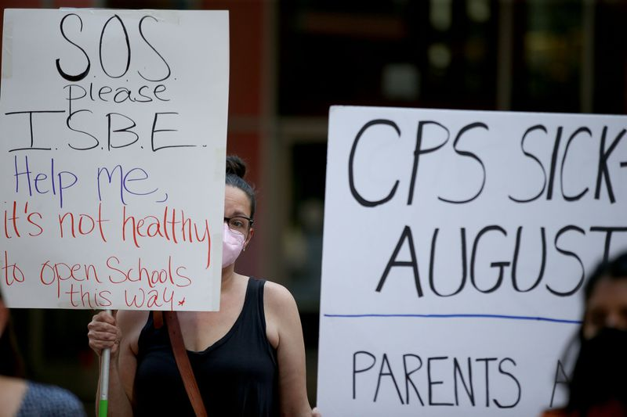

CPS is planning to welcome students back for in-person learning five days a week beginning Aug. 30.

(Antonio Perez / Chicago Tribune)

Gov. J.B. Pritzker’s COVID-19 vaccine requirement for school teachers and staff arrives as dozens of Illinois districts remain on probation for refusing to comply with the indoor mask mandate and hundreds of schools report possible exposures to the virus.

On Thursday, the Illinois Department of Public Health identified five schools with outbreaks and 307 schools with potential COVID-19 exposures based on contact tracing of people confirmed to have the virus.

At least 40 positive cases have been reported at Carlyle School District 1, which initially was not following the masking requirements, and more than 200 people are subject to quarantine, Illinois Department of Public Health spokeswoman Melaney Arnold said. Carlyle is located about 280 miles south of Chicago.

While contact tracing is continuing in an effort to identify all cases and close contacts, thus far, no one involved in the school district outbreak has been reported to have been hospitalized, Arnold said.

Pritzker announced the vaccine requirement Thursday for teachers and staff at pre-K through 12 schools, higher education employees and college students as part of an effort to slow the spread of the surging delta variant. The requirement comes as the state continues to face backlash to the indoor mask mandate for schools.

So far, the state has recorded 59 public school districts and private schools this month that were placed on probation or had their status changed to unrecognized for noncompliance with the mask mandate.

Several schools that now plan to comply have had their status restored, according to ISBE.

In her weekly message posted earlier this week, ISBE Superintendent Carmen Ayala said the school districts on probation for noncompliance with the mask requirement represent less than 5% of all districts and only 1% of the student population.

Ayala did not return calls for comment Thursday on Pritzker’s vaccine mandate for teachers and staff at Illinois schools.

While the vaccine requirement took some educators by surprise, many said despite lingering questions about how to comply with the new rule, a high percentage of their employees are already vaccinated.

“We’re still waiting to see what the actual order looks like, but some of our employee groups are already requesting to bargain the impact of the governor’s order,” Elgin-based Community Unit School District 46 Superintendent Tony Sanders said.

While Sanders is awaiting further details about the governor’s mandate, he said nearly 80% of the district’s 6,000 employees have reported that they have received at least one dose of the vaccine.

“We’ll make sure we’re compliant, and I fully appreciate the governor’s decision, but from an employer’s perspective, I need to make sure we don’t lose staff because of this mandate, because we can’t afford to,” Sanders said, noting that the district has been struggling to fill positions for bus drivers and other support staff.

At Arlington Heights-based Township High School District 214, a district spokeswoman said officials are also waiting to see the “full written order of the vaccination mandate to make sure we are in full compliance.”

“Up until this point, we have not asked our staff to disclose vaccination information,” District 214 spokeswoman Stephanie Kim said. She said the district was holding walk-in vaccination clinics Thursday evening for those attending open houses at the district’s six high schools.

At New Trier High School, about 90% of students and 92% of the staff are fully vaccinated, New Trier spokeswoman Niki Dizon said.

“The mandate issued by the governor today is consistent with New Trier’s current policy for staff,” Dizon said.

The district’s campuses in Winnetka and Northfield will offer Shield PCR saliva testing to all students and staff, and staff who are unvaccinated must participate in weekly testing, she said.

**---Elgin Courier-News--08/27/2021**

# Elgin police stationed at Larsen Middle School as a precaution after student fights

# by Gloria Casas Note: This article was also published at chicagotribune.com

AUG 26, 2021 AT 4:49 PM

Several fights this week at Larsen Middle School in Elgin resulted in police being on campus to ensure no more violence would occur, authorities said.

While the School District U-46 officials said there were two incidents, Elgin Deputy Police Chief Adam Schuessler said there was one fight Monday, two on Tuesday and a fourth on Wednesday. School District U-46 officials are handling the incidents but police were on hand at the 665 Dundee Ave. school as a precaution, he said.

Larsen Principal Marc Spacone sent a letter to parents to apprise them of what had happened.

“Staff and administrators immediately responded, separated the students, and met with all parents of the students involved,” Spacone wrote. “Discipline and consequences per our District’s Student Code of Conduct will be administered to the students involved in these incidents.”

He noted that videos of the fights were posted on social media and passed around by students.

“We can’t prevent students from filming others but we don’t encourage it,” Spacone wrote. “Please talk to your child about the residual impact of filming and posting such footage on social media as it may negatively impact those involved as well as our school community.”

Rumors of a “hit list” that would result in more fights at the school were investigated by police but found to be unsubstantiated, Schuessler said.

Spacone asked anyone with knowledge of possible fights that might occur to contact him or someone else at the school. “We are all here to work with you and your children and support a peaceful and positive learning environment for all,” he said.

The incidents are the first physical altercations at Larsen in more than three years, Spacone said.