**Press Clippings 02/28/20**

**---Education Week---02/28/2020**

**School Districts Are Suing JUUL Over Youth Vaping. Do They Stand a Chance?**

**By: Stephen Sawchuk, Denisa Superville**

[Enlarge](javascript:void(0))

Kim Kennedy, a school nurse consultant at Fairview High School in Boulder, Colo., holds confiscated vaping materials. *Nick Cote for Education Week*

School districts are at the head of a cresting wave of litigation against JUUL and other e-cigarette manufacturers, seeking to recover the costs of prevention programs, counseling, and treatment for addicted students.

Nearly 100 districts have sued, and the dozens of filings indicate that the epidemic of youth vaping has penetrated nearly all corners of the nation's public education system-from a small, rural district in Mississippi to the nation's second largest school system, Los Angeles.

Although some of the fundamental claims in the lawsuits reflect those in litigation over tobacco and opioid medication, school districts' primary role in fighting back against vaping comes as a novel development in consumer-protection litigation, and reflects that they've become the de facto first responders to the crisis.

"School districts, by no control or choice of their own, have effectively become ground zero for the infiltration of JUUL's marketing and the epidemic JUUL has created," said Rahul Ravipudi, a partner at Panish Shea & Boyle LLP, and one of the lawyers representing Los Angeles and other California districts in a case filed in state superior court.

In interviews, superintendents said their interest in suing stems from both a desire to shape whatever settlement or monetary damages the suits could produce and a moral imperative.

"Who is better positioned than a superintendent of schools to take a stand on this issue?" said Rob Anderson, the superintendent of the Boulder Valley district in Colorado, which is in discussions to join one of the lawsuits. "We are leaders within our communities for what's right and what's good for kids. And I take that obligation, personally, very seriously. I do think we can fight this fight, and that if not us, who?

## Three Waves

By Education Week's tally, nearly 100 districts have filed a lawsuit against JUUL, and other manufacturers of vaping devices.

The lawsuit first filed in California Superior Court in October is now a consolidated case counting about 20 school districts in the Golden State, with more in the works, Ravipudi said.

At the federal level, at least 33 school districts' lawsuits have been wrapped into a consolidated case now housed at the U.S. District Court in California for the Northern District. (About two dozen other federal lawsuits have been filed by districts but have not yet been transferred to the multidistrict litigation.)

Within both of those consolidated lawsuits, some districts have sued on their own behalf while others have requested certification as class actions. If granted by the respective courts, those cases would cover thousands more school districts.

Finally, the attorneys general of at least eight states plus the District of Columbia have sued in their own state courts: Arizona, California, Massachusetts, Minnesota, New York, North Carolina, and Pennsylvania. (A larger group of attorneys general-39-have joined together to open an investigation into JUUL's marketing practices, including whether it targeted underage users.)

Nearly all the lawsuits target Juul, by far the most dominant e-cigarette manufacturer with about 60 percent of the market. Others name PAX Labs, which birthed JUUL; Altria, a tobacco company that owns a significant stake in JUUL; and Eonsmoke, a New Jersey-based e-cigarette manufacturer. A handful of the lawsuits also take aim at various distributors of vaping products.

## Counting Costs

Most districts have been fairly vague on specific costs they're incurring, information which will need to be disclosed during discovery should the lawsuits proceed to the trial stage. But interviews with the districts paint a wide-ranging picture of the toll, both personal and financial.

For Anderson in the Boulder Valley district, one of the most difficult tolls has been hearing the stories of parents whose children have become addicted to nicotine through vaping.

"You've got parents who love their kids and who are involved in their lives, and kids who didn't know what they were signing up for when they started to vape," Anderson said. "They get addicted and then there are these serious health complications in their lives. These are active, healthy kids, and the fact that they started vaping has changed their families' lives."

In the last few years, the Boulder Valley district has received about $1.2 million in city and state grants to spend on anti-vaping and other substance abuse prevention efforts. The La Conner district in Washington state last year spent about $12,000 for vaping detectors in the bathrooms and an online subscription to a service that alerts administrators if vaping is detected.

In Rochester, N.H., already heavily hit by both the Great Recession of 2008 and the opioid crisis, the increase in vaping in schools has led to costs for multiple city agencies, said Terence O'Rourke, the city attorney. Buying and smoking tobacco products while underage in in New Hampshire are classified as adult offenses, and so students who get caught vaping have to be processed through the city's alternative-sentencing program.

Among the city's other costs: Hiring a monitor to prevent vaping at the city's community center-the home of its alternative high school, and where much of its youth programming takes place. The new position costs $32,000 annually.

"This is not a money grab by the city. We need the resources to undo the damage that's been done to our kids," O'Rourke said.

Adrian Hammitte, the superintendent of the 1,150-student Jefferson County schools near Natchez, Miss., estimated his district lost $200,000 in the 2018-19 school year, the result of skyrocketing student absences due to vaping that have led to less per-pupil funding, which is allocated on the basis of attendance.

"It's about having a seat at the table," said Hammitte, when asked about his district's decision to sue. "Vaping is impacting our students, too, and if you don't have a seat at the table, you don't have a voice. And we wanted a voice in the conversation."

It's unclear what all the costs borne by districts would add up to in total. In California alone, Ravidpudi said he is still surveying participating districts on costs and declined to give a ballpark figure.

But it's clear that it could be substantial. Attorneys in the Jefferson County, Miss., lawsuit estimated that, if that case is certified as a class action to cover all of Mississippi's districts, claims would amount to more than $5 million.

## Legal Strength

The districts' participation in the litigation represent an evolution in how local government is viewing both the costs and its role in responding to public health crises.

A landmark 1998 tobacco master settlement benefited states but frustrated county and municipal governments after states spent only a small share on treatment and prevention programs, noted Kathleen Hoke, a professor of law and the director of the Network for Public Health Law, Eastern Region, at the University of Maryland's law school.

And so during subsequent litigation, such as the ongoing opioid litigation, municipalities often beat states to the courthouse. Similarly, districts are now asserting their muscle over vaping, she said.

What isn't clear is whether courts will be receptive to the districts' arguments. There's no question that schools are spending thousands to respond to addicted students' needs, Hoke said, but what the courts will need to determine is whether Juul and other vaping manufacturers are directly responsible for that harm, she said.

"They are going to say they have abided by all the federal laws and state laws that have existed, and have complied in the regulatory scheme and can't be liable for this tertiary impact," Hoke said. "That's the strongest argument for Juul, and it's a good one."

Representatives for JUUL did not respond to a request for comment in time for publication.

But the districts have advanced powerful arguments, too, notably their contention that companies deliberately aimed to hook young people on vaping. They have pointed in particular to JUUL's marketing, including the use of young, attractive social media "influencers" to promote the products, and its creation of candy- and fruit-flavored vapes.

Several of the lawsuits also reference an anti-vaping curriculum JUUL allegedly encouraged schools to use that, attorneys for the districts argue, actually downplayed vaping's health risks. (JUUL contends that it did not market its products unlawfully towards youth and has pointed out that it voluntarily took fruit and candy-flavored vape flavors off the market.)

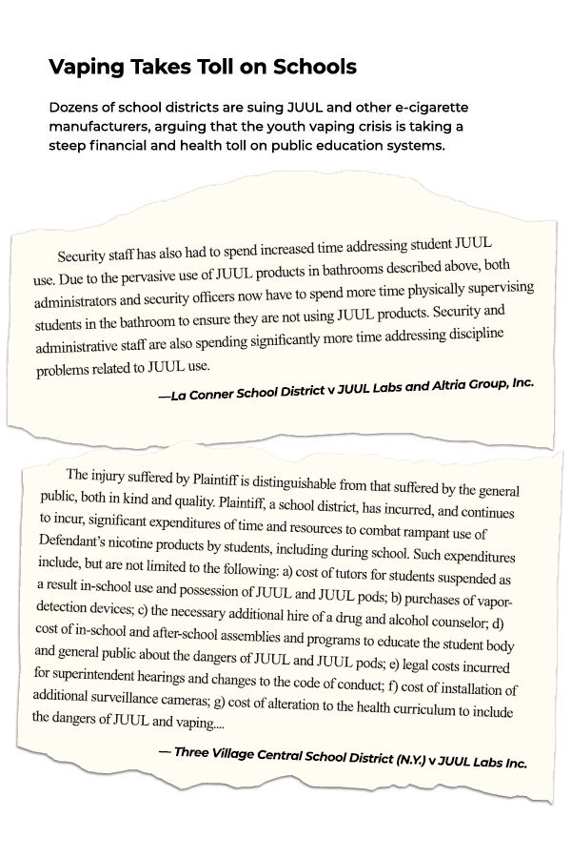

"I don't think it's a slam dunk on either side," Hoke said.

Lynn Rossi Scott, an attorney at the Fort Worth, Texas, law firm Brackett & Ellis, agreed that the legal questions are open ones.

"I do see this is a growing trend, and I think it's just going to take the first case that actually gets before a judge to make a determination whether or not a district has standing," said Rossi Scott, who has not read the litigation. "I liken this to the asbestos cases from many years ago, where it was very clear that the school districts had standing because they had to conduct significant remediation efforts in their schools to remove asbestos or seal asbestos.

There were very significant damages. These cases, I think, are a little more speculative, and a little more difficult to prove damages. But let's wait and see."

Neither Hoke nor Rossi Scott is involved in any of the cases.

## More to Come?

As with any civil litigation, higher numbers amp up the pressure on companies to reach a settlement. And there are signs that interest could be growing.

Vaping was enough of a priority for districts that it was a topic of a session at the recent national conference for AASA, the School Superintendents' Association, at which Mark P. Chalos, an attorney with Lieff Cabraser Heimann & Bernstein, whose firm was named as one of four co-lead counsels for the federal multidistrict litigation, spoke.

Chalos said he expects more lawsuits to be filed, but he thinks school boards, superintendents, parents, and district officials are still in the beginning stages of understanding the impacts of vaping.

"I think we are at a relatively early stage in the awareness being raised on this issue," he said. "I would expect that unless we can stem the tide of the vaping crisis, we're going to see more children vaping, and more teachers and school administrators and parents will become aware of it. Whether that results in more school boards or parents or children participating in the civil justice system remains to be seen."

Indeed, at the same conference, some superintendents worried that they were underestimating just how prevalent it was in their schools-with several acknowledging that they could not distinguish vaping devices from a random assortment of technology bric-a-brac, including a USB drive and an Amazon Fire Stick.

"My realization with that session was that we've not even scratched the surface. It's really scary to think about the many devices out there we've not even seen or captured," said Tony Sanders, the superintendent of the U46 district in Elgin, Ill. His district has already started picking up, at $24,000 annually, the full cost of an online program designed as an alternative to suspending students who are caught with drugs or alcohol, in which both parents and students participate.

He's planning to discuss with his school board whether to join a lawsuit.

Joelle Rossback Dahl is the co-founder of Advocates for Clean Teens, a parent-advocacy group for teens with substance abuse in Boulder, Colo., which worked with the Boulder Valley district on many anti-vaping efforts, including pushing for the Boulder City Council to pass several anti-vaping ordinances last year.

Dahl, who has watched a fellow parent struggle to help their child quit vaping, thinks the district should join the growing number of school systems taking the fight directly to e-cigarette companies.

"At the end of the day, this isn't a school problem, this isn't a parent problem," she said. "This is a Big Tobacco-and-FDA-having-allowed-this problem... It's not the school's fault, and it's not parents not doing their jobs. The best of the parents can have kids who are vaping. It just needs to be a holistic effort-the city, the community, the schools, the medical community, you name it. But these kids have been swindled by Big Tobacco, and it's really, really disheartening."

**---Daily Herald---02/28/2020**

**How suburban schools are preparing for the coronavirus**

**By:** [**Madhu Krishnamurthy**](https://www.dailyherald.com/newsroom/MadhuKrishnamurthy/)



School districts across the suburbs are emphasizing preventive good hygiene practices as officials brace for coronavirus spreading in the region. Most districts don't have preparedness plans, but are using measures in place for flu and other communicable disease outbreaks.

Cleaning classrooms and monitoring student attendance and sickness are among the precautions suburban school districts and preschools are taking to prepare for a potential coronavirus outbreak.

Across the suburbs, schools officials are especially emphasizing good hygiene, such as hand-washing, as they brace for the virus' spread to the region. Most districts don't have preparedness plans, but are using measures in place for flu and other communicable disease outbreaks.

Officials are looking to county and state health departments for guidance on how to protect students, families and employees.

At Round Lake Area Unit District 116, officials are tracking daily attendance across 10 schools and monitoring how many students call in sick with fever, cough, sore throat, shortness of breath, diarrhea and vomiting, encouraging parents to keep them home.

The district followed this protocol during the 2009 H1N1 (swine flu) pandemic, said Heather Bennett, district spokeswoman.

"This is not something that we typically do," Bennett said, adding officials are tracking use of medical supplies and are more focused on influenza and other common illnesses around this time of year.

The global coronavirus outbreak has infected 82,294 people in 47 countries and claimed the lives of 2,804 people -- 2,747 in China and 57 elsewhere as of Thursday, according to the World Health Organization.

The Illinois Department of Public Health reports two confirmed and two suspected cases of coronavirus, and the Centers for Disease Control and Prevention warns of the potential for the virus spreading in communities nationwide.

Suburban school districts say they are working closely with health departments and urge following their directives to prevent the spread of illness.

That includes washing hands often with soap and water, using alcohol-based hand sanitizers, avoiding touching eyes, nose, and mouth with unwashed hands and close contact with sick people, staying home when sick, covering coughs and sneezes, and cleaning and disinfecting frequently touched objects and surfaces.

"We have plans in place in the event of a pandemic, but that is not unique to this virus," Elgin Area School District U-46 CEO Tony Sanders said. "We are reviewing and seeing what may need to be adjusted as more information comes in from CDC and health departments."

Those precautions include tracking illness trends, proactively cleaning classrooms and schools, and sending sick students home to reduce exposure to others.

School superintendents have been trying to allay parents' fears through email messages and communications posted on district websites. "We continue to be proactive in our cleaning practices," wrote Jeff Schuler, superintendent of Wheaton-Warrenville District 200. "Over this long weekend, we are deep cleaning the surfaces at each of our schools. Staff members are reminded to promote universal precautions among students, including frequent hand washing. In addition, we will monitor all travel for any school activities that may be affected."

Officials at Palatine Township District 15 say they are awaiting health departments' guidance on coronavirus response. In the meantime, they are taking the same precautions as for cold and flu season, spokeswoman Morgan Delack said.

"If we have multiple cases of influenza in the building, we would definitely clean doorknobs and tabletops," Delack said. "We don't proactively bleach things unless a need arises."

Aurora-based Two Rivers Head Start Agency is making face masks available at its 10 sites, including preschools in Aurora, Carpentersville and Elgin, for students, employees and visitors exhibiting signs of illness. The agency serves 893 children from 6 weeks up to 5 years old.

"We have an emergency preparedness plan," Executive Director Diane Lacey said. "As people enter, we are having them wash their hands. We do a wellness check when the children come in. If staff are sick, we send them home."

Parents may not be as alarmed about the virus, as school districts report few inquiries. Several U-46 parents downplayed concerns in comments made Thursday on a Facebook group.

"Not concerned about the illness itself at all. Concerned about the panic mongering and over reaction of paranoid people," wrote Todd Warren.

Christina Liptak-Riess echoed precautions district officials advise: "Cover your mouth. Wash your hands. Stay home if you don't feel well."

**---The Courier-News ---02/28/2020**

**U-46 to examine covering textbooks**

Reduction of cost for those in dual credit courses

**By: Rafael Guerrero**

School District U-46 is looking at a reduction in textbook costs for students who are taking classes in which they earn both high school and college credit.

Officials this week introduced a $1.1 million proposal that would pay a $425-per-semester textbook stipend to families of students enrolled in the full-time Accelerate College program at Elgin Community College.

It also calls for the district to purchase the textbooks used by students enrolled in dual-credit classes being offered in the high schools this fall.

“We’re here because we want to provide access for our students and to remove barriers,” U-46 Post-Secondary Success Director Michele Chapman told school board members Monday night. “In order to do that, we need your help.”

The school board will vote on the measure next month. If approved, both initiatives would go into effect next school year and run through the end of the 2023-24 school year.

Broken down, the digital and print textbook stipend for parents would cost the district $340,000 — about $85,000 annually through 2024, Chapman said. The remaining $760,275 requested would cover the cost of online license fees and textbooks used in high school dual-credit classes, she said.

The proposal would cost U-46 an average of $265 per student in the first year, but the average cost will drop over the next few years, officials said.

Beginning in the 2020-21 school year, nine dual-credit courses will be available to students in the high school, including courses in math, English and Spanish. The cap on the number of students who can take the classes is 1,500.

“We’re in the process of figuring out (teacher) staffing,” Chapman said. “Those teachers that have been approved will have professional development with ECC (later this year).”

To be considered, teachers must have a master’s degree or graduate credit in the content area they’d be teaching and will undergo a review process conducted by ECC, she said.

This year there are 47 high school seniors currently enrolled at ECC to earn both high school and college credit. Next year, enrollment will increase to 100 as high school juniors participate for the first time.

**SPORTS**

**---The Courier-News ---02/28/2020**

**The sudden Storm**

Rivera and upstart South Elgin bask in the moment after finishing in 7th place in second straight appearance at state finals

**By: Matt Le Cren**

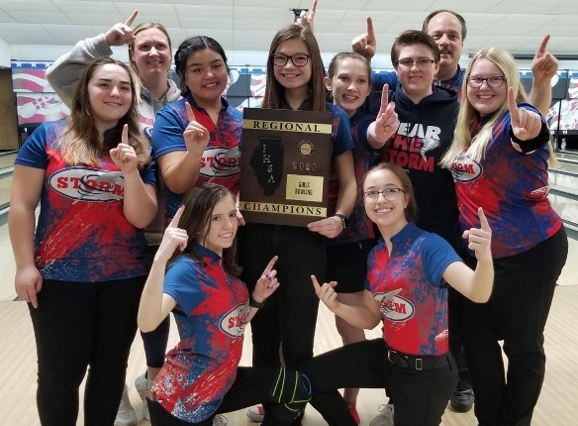

The South Elgin girls bowling team shows off the Dixon Regional championship trophy on Feb. 8. Team members are Samantha Thaller, back row, from left, coach Nicole Maciorowski, Mia Rivera, Karlea Ceasario, Monica Darrow, McKenna O’Donnell, coach Mike Anzalone, Delaney Brown; and Kaylee Mann, front row, from left, and Breanne Augustine.

South Elgin junior Mia Rivera has been bowling since her grandfather introduced her to the sport when she was a little girl.

She and her teammates practiced their craft in relative obscurity until last season, when they became the first girls sport to qualify for the state finals.

The Storm brought everyone back from that team, which finished 11th, and they did even better this season.

With Rivera and junior Breanne Augustine leading the way, South Elgin finished seventh at state finals at Cherry Bowl Lanes in Rockford last weekend with 11,179 pins (186.3 average). Rivera was 32nd individually (198.7 average), and Augustine finished 47th with 2,303.

“It just means so much to us,” Rivera said. “A lot of people at school didn’t even know we had a bowling team, and other bowling teams didn’t know who are school was.

“Now we go to tournaments, and people look out for us. They recognize us and know who we are. So it’s a big deal that we turned the team from nothing into something where we’re going to state twice in a row.”

Rivera credited first-year coach Mike Anzalone for the Storm’s improvement.

“He really helped us a lot,” Rivera said. “I knew him before, but not that well.

“I really got to know him better during the school season. This year we came together more as a team and did a lot more team bonding, so we’ve been connecting better.”

Anzalone has connected with the girls, several of whom he worked with through the youth league he runs at Poplar Creek Bowl.

“It’s been fun to work with them,” Anzalone said. “It’s been cool to be part of their high school career. They just put in a lot of effort all year.”

The team also includes seniors Karlea Ceasario and McKenna O’Donnell and juniors Monica Darrow, Kaylee Mann, Delaney Brown and Samantha Thaller.

Ceasario was 51st (2,283), and Darrow finished 65th (2,200). Mann scored 1,881, and O’Donnell bowled one game at state.

It was the culmination of a historic season that stoked the interest of the school community.

“When we found out we were going to state, they had a send-off for us,” Rivera said. “We had a Coach bus and a police escort with firefighters.

“They gave us breakfast, and a band came out and played for us. It was really touching that they would do that for us.”

Rivera also credited the group of parents known as “Storm Chasers” for fueling their rise.

“We feel so grateful that (we have) such a big supportive family,” Rivera said. “We’re all one big family, and all the parents are always helping out everyone and always cheering us on.

“Even if we’re five lanes down, we still hear them in the background motivating us.”

The Storm are motivated to continue their rise.

“That’s our goal — to be one of the teams that everybody knows and recognizes,” Anzalone said. “They’ve made a lot of impressions on a lot of teams and coaches this year.

“It’s been really fun to get those comments back from other teams and other coaches about our professionalism.”

Now the team is the vanguard of the athletic program.

“It’s pretty cool because I never thought that bowling would be such a big deal at the school,” Rivera said. “Having the school recognize our talent is pretty big for us.”

Rivera can’t wait for what’s next, including a possible collegiate career.

“Whenever the school season comes around, I always get so excited,” Rivera said. “If I’m able to do that in college too, I’ll be happy.”