**Press Clippings 2/12/2022 to 2/14/2022**

**Chicago Tribune/The Courier-News**

**Elgin News Digest --- 2/11/2022**

**By Mike Danahey**

### **DXP donates tools to U-46′s manufacturing programs**

The precision manufacturing programs at South Elgin and Streamwood high schools have received more than $200,000 in tools from industrial distribution business DXP Enterprises.

John Zauner, a member of School District U-46′s Precision Manufacturing Advisory Committee, is DXP’s Illinois sales manager and arranged for the donation.

Zauner, a graduate of the Streamwood High School’s precision manufacturing program, said the tools are a way to ensure current students have the same opportunities he had while in school.

In precision manufacturing classes, students receive hands-on training in precision measurement and learn how to operate lathe, milling and grinding machines. The curriculum prepares students for the computer numerical control systems used in modern manufacturing.

Streamwood precision manufacturing instructor Matt Erbach said the donation is a welcome opportunity to upgrade the schools’ older equipment.

### **U-46 foundation scholarship applications now available**

Applications for nine scholarships offered through the School District U-46 Educational Foundation are available online at [**www.u-46.org/cms/lib/IL01804616/Centricity/Domain/1576/Scholarship%20Profiles.pdf**](https://www.u-46.org/cms/lib/IL01804616/Centricity/Domain/1576/Scholarship%20Profiles.pdf).

Four of the scholarships are offered only to students who will be graduating from Elgin High School. One is specifically for someone from South Elgin High School, and four are for students meeting certain qualifications from any of the district’s five high schools.

Amounts available range from $1,000 to $4,750.

Students need to complete one application in order to be considered for any of the scholarships. The deadline to apply is 11:59 p.m. Sunday, March 6.

For more information, call Dawn Curran at 847-888-5000, Ext. 5040, or email her [**atdawncurran@u-46.org**](mailto:atdawncurran@u-46.org).

**Daily Herald**

**Retiring Streamwood coach Rosner made ‘Beautiful Noise’ for 40-plus years --- 2/12/2022**

**By John Radtke**

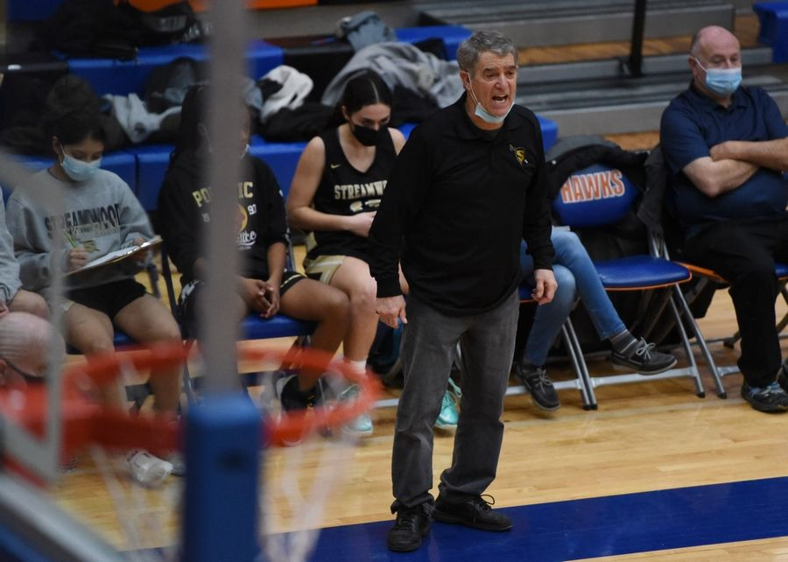

Streamwood girls’ basketball coach George Rosner is retiring at the end of the season. He has coached for nearly 50 years. *Paul Valade | Staff Photographer*

If you've ever been to a Streamwood girls basketball game, then you know that Sabres' coach George Rosner is a big fan of iconic musician Neil Diamond.

Rosner blares Diamond music during every practice -- and even at games now and then -- and has been for 40-plus years.

His favorite Diamond song and album is Beautiful Noise, which was released in June of 1976. On a Zoom call earlier this week, Rosner showed me the original album cover, and by original, I mean vinyl and not a CD.

Rosner is retiring from coaching at the end of the Sabres' season, which could come as early as Monday when his team faces top-seeded Barrington in the semifinals of the Class 4A Barrington regional.

A graduate of St. Ignatius Prep and Northeastern Illinois University, Rosner's coaching career began at St. Monica grade school in 1973.

"I coached softball and then the second year I was there, the boys’ basketball coach came to me and said we were going to get kicked out of the conference if we didn't have a girls’ basketball team," Rosner recalled. "A lady named Bernadette Shields (mother of longtime boys’ basketball coach Tom Shields) said, ‘I'll do it if you do it.’"

And Rosner's girls’ basketball coaching career was born. One year, he coached both a boys’ team at Our Lady of Victory, and his girls’ team at St. Monica, a total of 90 games by his count.

"My very first game, Patty Griffin scored the first basket, made a free throw and we were up 3-0. I thought 'Hey, I got this,' " Rosner said. "We lost that game 39-3.

"But the last year (at St. Monica), we won 47 games, won the city championship and we were featured on ABC 7 by Tim Weigel.

Then, in 1979, longtime boys’ basketball coach and Elgin resident Tom Yore was leaving Weber for a new school in District U-46 -- Streamwood.

"Tom needed some assistant coaches and there was a social-studies opening (at Streamwood), Rosner said. "I left the grade school reluctantly and came to Streamwood, where I was the assistant sophomore boys’ coach under Kerry Sund, and Tom used me as his scout. I learned a ton of basketball from doing that."

In 1980, the school's first Streamwood girls’ coach, Sue McIntyre, became a counselor and had to give up coaching, Rosner said.

"The AD, Roger Smith, came to me and asked if I'd be interested in coaching the girls' team, " Rosner said. "It was rough. The first year we won two games, then four, then six."

The 1983-84 season produced Streamwood's first winning season (13-12), and began a run of eight-straight winning seasons, a stretch that included four-straight regional titles and, in1988, a 26-4 campaign that ended with a 52-49 loss to York in the Class AA Batavia supersectional.

That team included Donna Groh, probably the best girls’ basketball player ever at Streamwood who went on to play at Northwestern, and Renee Kanak, still the program's all-time leading scorer.

"And then I had this little girl named Chris Francke," said Rosner who has kept a comprehensive book as well as scorebooks from every team he's coached back to 1973. "She ended up being an all-state player."

Francke went on to play at DePaul for Doug Bruno, one of the greatest influences in Rosner's career. Rosner worked Bruno's summer camps for 20-plus years, a time when he coached a player from Elk Grove named Babbi Barriero, now the longtime Barrington coach who Rosner will coach against on Monday.

The lean years followed after 1988 and not until 2013 did the Sabres win another regional title (their last regional title season was in 2017.

"That one (in 2013) really renewed me," said Rosner, who retired from teaching in 2012 and who will retire from an IBCA Hall of Fame career with over 400 wins. "I really thought about giving it up after a couple of bad years in the 2000s, but I stayed on. We had players like Emma Schmitt, Michelle Tomczak and Jessica Cerda come in and we were pretty tough again.

"But now I have two grandchildren I didn't have a year and a half ago. I'm 70, and it's just time. I'm glad I stayed with it and I'll absolutely miss it."

Rosner is quick to credit his wife, Kathy, and their sons, George Jr., and Joey, for their support. He also has a short list of coaches who influenced his career, and who he had some great battles with.

"Tom Yore, Doug Bruno, Will Rey, Derril Kipp and the original group of coaches in the Upstate Eight," Rosner said. "Lee Turek at Elgin ... man, we had some battles. We ended their season several times, and they ended ours. We also had some good battles with Denise (Sarna), when she was at Bartlett."

Now, in the twilight of his career, Rosner leaves with many fond memories but also some bitterness over the school dedicating the gym as Rosner Arena in December, only for that not to be honored by U-46 administration due to an obscure policy that doesn't allow anything to be named after someone while they're still alive, Rosner said. Thus, Rosner Arena, after widespread media coverage, is no more.

"It was good, positive publicity for Streamwood, which has had a lot of negativity over the years," said Rosner, who cited the night the gym was dedicated to him as, "one of the greatest nights ever."

"What hurt me the most was knowing there was a compromise in place to leave it up for the season and that was turned down. Maybe it wasn't done perfectly but it could have been left up for the season. Am I bitter? Yes. Am I hurt? Yes. But they can't take that night away and the positives of that night will never be forgotten"

Nor will the Beautiful Noise Rosner has emulated for more than 40 years.

**Chicago Tribune/The Courier-News**

**Into the great ‘wide open’ goes Fernando Perez Jr. Larkin’s senior guard gets his moment with a game-winning layup against East Aurora --- 2/11/2022**

**By Paul Johnson the Aurora Beacon-News**

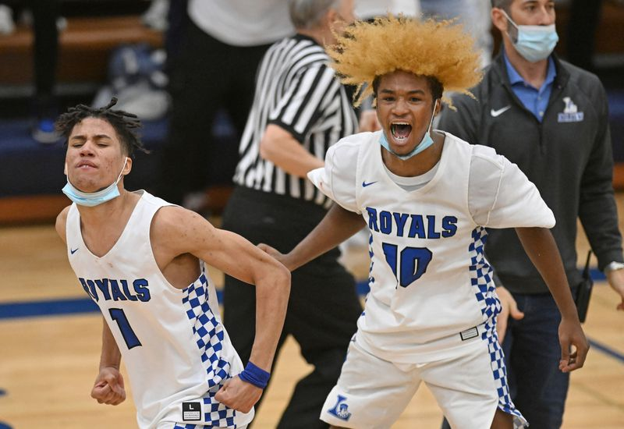

Larkin’s Fernando Perez Jr. (1) and teammate Damari Wheeler-Thomas (10) celebrate after a 62-60 win against East Aurora in Elgin on Friday, Feb. 11, 2022. (Brian O’Mahoney / The Beacon-News)

Fernando Perez Jr. might not get the recognition other 1,000-point career scorers get, but Larkin knows his value.

“He’s overlooked from the outside, but not inside our program,” Larkin coach Deryn Carter said. “We know his importance. We know we’re not where we are without him. It’s definitely nice to get Nando a little bit of recognition on senior night.”

The senior guard found himself in the spotlight late in the Upstate Eight Conference game against visiting East Aurora on Friday.

Perez slipped under a screen, and senior guard Jamarion Stubbs found him for the game-winning layup in the final seconds as the Royals escaped with a 62-60 win to remain unbeaten in the UEC.

Stubbs was set to inbound the ball with 0:04.3 on the clock. Perez set a pair of screens for senior guard Damari Wheeler-Thomas and then got under the second screen to give him a wide-open look for the game-winner.

“Carter told me after I set the double screens for Damari, ‘Just slip, and it will be wide open,’” Perez said. “I just trusted him, and it was wide open. It’s a great moment. I’m going to remember it forever.”

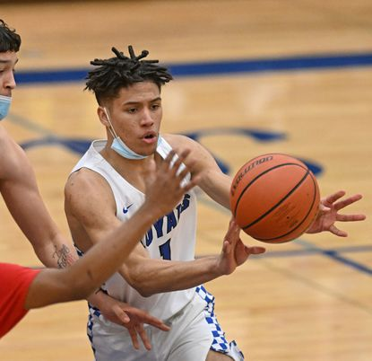

Larkin’s Fernando Perez Jr., right, passes the ball under pressure during a game against East Aurora in Elgin on Friday, Feb. 11, 2022. (Brian O’Mahoney / The Beacon-News)

East Aurora (16-10, 10-6) took a 58-57 lead on junior guard/forward Jabian Acosta’s free throw with 1:30 left. Wheeler-Thomas took the lead back for Larkin (26-3, 17-0), converting a 3-point play with 1:14 to go. Sophomore guard Calvin Savage then tied it at 60-60 with a pair of free throws with 1:00 left.

But the Tomcats didn’t get the ball back. Larkin worked the clock until the final seconds, calling a timeout to set up the last play.

“The way they were concentrating on Damari, we set a screen and then rescreened, and man, they executed the heck out of it,” Carter said. “It doesn’t matter what you draw up if it’s not executed. The kids executed at a high level.”

Perez, who finished with 18 points, said experience played a role in the final play succeeding.

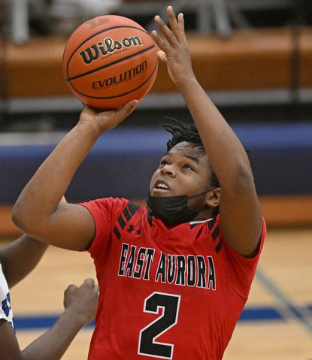

East Aurora’s Calvin Savage (2) puts up a shot during a game against Larkin in Elgin on Friday, Feb. 11, 2022. (Brian O’Mahoney / The Beacon-News)

“Our sophomore year, we would have thrown the ball away and thrown the game away,” Perez said. “We stayed composed and found a way to win.”

A dominant second quarter gave Larkin a 36-24 halftime lead. Wheeler-Thomas scored 10 in the second, and Perez added eight.

The Tomcats held Wheeler-Thomas scoreless in the third, however, and clawed back into it. Savage’s 3-pointer with 6:40 left in the fourth gave East Aurora a 48-47 lead and set up a back-and-forth finish.

“East Aurora always plays us tough,” Perez said. “I wish we had more teams like them in our conference. Any time we play East Aurora, it comes down to the wire — every time. This was great for us going into the playoffs. We needed it.”

Senior guard Jullian Acosta led East Aurora with 17 points. Savage added 14, junior wing Ralph Clark scored 12 and Jabian Acosta scored 10.

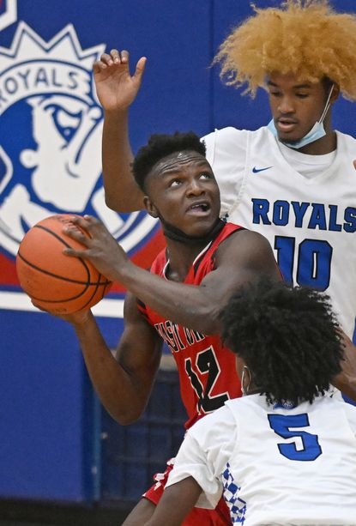

East Aurora’s Ralph Clark (12) tries to get a shot up against Larkin’s Damari Wheeler-Thomas (10) and Jamarion Stubbs (5) during a game in Elgin on Friday, Feb. 11, 2022. (Brian O’Mahoney / The Beacon-News)

Wheeler-Thomas led all scorers with 20 points. Sophomore guard Jakob Blakley scored 11, and senior forward Dontrell Maxie grabbed 10 rebounds.

The win was the 200th of Carter’s coaching career.

“It means a lot of good players,” Carter said. “It means a lot of good coaches. It means a lot of good sacrifices made from a lot of people. It’s not an individual accomplishment. It’s a program accomplishment, and I’m proud of it.”

The Royals have already wrapped up their second straight UEC title and a No. 1 sectional seed. They’re ready to make their postseason run.

“Now it’s about seeing if we can get one possession better,” Carter said. “We like our chances when we play our game.”

|  |
| --- |
|  |
|  |

**Daily Herald**

**Fast start propels Fremd to win over South Elgin --- 2/12/2022**

**By Dick Quagliano, Daily Herald Correspondent**

Sometimes it is all about the start.

For Fremd, its engine was firing from the first turn of the key.

The Vikings bolted to a 15-2 lead and then had to hold onto the wheel for a few minutes for a 75-61 win over South Elgin Saturday in a nonconference boys basketball game in Palatine.

After a disappointing loss to Conant on a last-second shot on Friday, Fremd came ready to play Saturday.

"I thought we played very hard last night," Fremd coach Bob Widlowski said. "We told the kids that having a game Saturday was the best thing for us. These kids never put their heads down. We bounced back tonight and we bounced back on both ends of the floor."

Fremd (17-9) came out firing on cylinders on Senior Night. And the Vikings got some spark from some unusual sources thanks to Aaron Orido and Sevag Aroyan as they built a 17-6 lead.

"It was a real good team effort tonight," Widlowski said. "We spread it around and we shared the ball really well. Our defense was also a key and it led to some baskets."

Fremd forced South Elgin (15-14) to turn the ball over five times early in the game. Chris Smyros and the Vikings then heated up even more. Fremd converted 14 of its first 22 shots as the Vikings surged to a 32-15 lead.

"It was a very fun night," said Smyros, who finished with 21 points. "We came out great and we executed well. We really wanted this one tonight after a tough loss last night."

South Elgin, which has suffered through numerous slow starts according to coach Brett Johnson, finally was able to settle into the game.

"We have started all games against quality opponents with slow starts," Johnson said. "And we have had to battle back. And we have battled back every game."

The Storm did battle back on numerous occasions Saturday, only to have Fremd dig in even deeper.

South Elgin got its deficit down to 10 points late in the second quarter. But the Vikings scored the final 5 points thanks to a 3-pointer by Cameron Kuhl as they led 40-25 at the break.

Fremd looked like it would blow the game open in the third quarter as it surged to a 57-38 lead.

"We had Senior Night, so I knew I wasn't going to be starting," said Vikes junior Ryan Sammons, who finished with 18 points. "Coming off the bench, I was just trying to give my best effort and do what the team needed."

Led by Rocco Marzullo (14 points) and Drew Cwik (13 points), the Storm got it down to 63-56 on Cwik's 3-pointer with 5:08 to play.

But a timeout by Widlowski quickly righted the Vikings' ship. A pair of inside baskets by Caiden Suchy helped the Vikings close out the game on a 12-5 run.

Fremd had eight different players score including Eli Schoffstall, who had 8 points. Orido, Suchy and Kuhl each had 6 points. South Elgin had nine different players score. Brian Vesta and Josh Gene each had 8 points.

|  |
| --- |
|  |
|  |