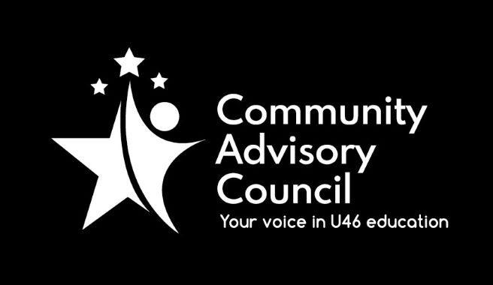

Community Advisory Council

Executive Committee Meeting Minutes
November 18, 2021
- Call to order: Meeting was called to order at 7:01 pm. Meeting was held via Zoom and attended by Chanda Schwartz, Tracy Kelly, Michael Johnson, Matt Hovey, Sarah Siddiqui, Karla Jimenez and guests
- Approval of minutes from October 21, 2021, meeting: Motion to move to next meeting made by Chanda Schwarz, seconded by Michael Johnson, all approved.
- Public Comment: None
- Administrative Update: Administrative update provided by Karla Jimenez. There will be a vaccine clinic held on November 19, it is the first round for elementary students, second clinic to be held in December. Staff vaccine clinics will be held on November 20. Plenty of job opportunities in the district, there will a job fair promotion on social media.
- CAC General Meetings Discussion-December Roundtable: Roundtable to be held virtually, will have various break out rooms, with district administration and staff moving about the rooms. Advised to set rules ahead of time, suggesting to participants to stay on topics and tasks at hand, being respectful of other participants and addressing issues not specific people. Need to reach out for interpreters to help out.
- Committee Updates: Michael Johnson of Instructional Initiatives stated that November meeting on 1:1 technology had 3 attendees. Next meeting would be held January 11 at 7:00 pm, topic will Restorative Practices. Equity & Discipline. Matt Hovey of FACE stated that meeting on October 28 was well attended, and next meeting will be held January 27, discussing the Six Components of Family Engagement. Chanda Schwartz of Specialized Student Services stated that. SSS will hold their next meeting on December 14.
- Strategic Discussion – CAC Membership Outreach: Future plans of the committee include working with other committees to increase awareness of parent advisory boards, possibly doing an event together.
- Other Business: None
- Adjournment: Motion to adjourn made by Sarah Siddiqui, second by Michael Johnson. All approved and the meeting adjourned at 7:46 pm.

Minutes submitted by: Tracy Kelly on January 19, 2022
Minutes approved by:

