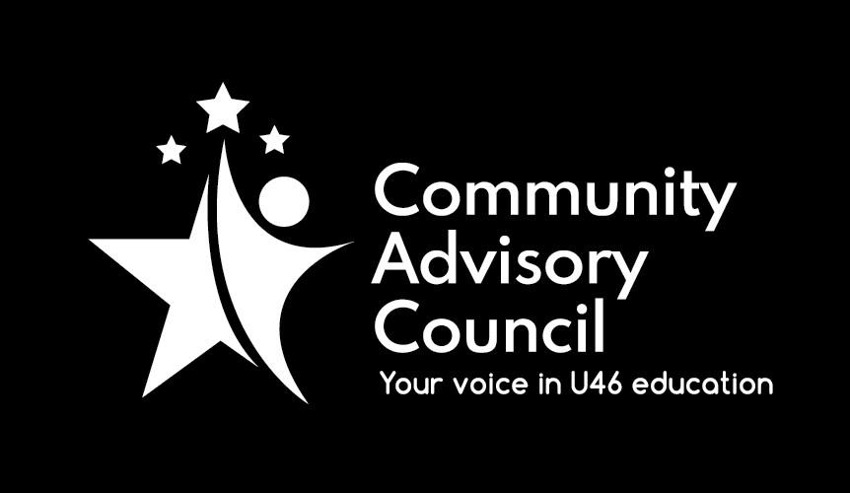

General Meeting Minutes
Meeting Date – October 7, 2021
- Call to order:
Meeting was held via Zoom and called to order at 7:03pm. Meeting was attended by members of Executive Board, school representatives and District administration staff (sign in sheets). Translation provided by Karla Jimenez
- Approval of minutes from May 6, & September 9, 2021, meetings: motion to approve by Michael Johnson, second by Ginger Kurtz, all approved.
- Board of Education Update: There was no Board of Education update
- Administrative Update: Provided by Karla Jimenez, who thanked the speakers for the evening and introduced the administrative staff that were attending. October is National Principal’s Month, please recognize your school’s principal for all their hard work. There will be a “no-cook” night on October 19 at Culver’s on Mclean in Elgin. Please mention U-46 Superintendent Scholarship when placing orders. Explore Expo 2021 was held October 7, thank you to ACE for holding this event. Magnet Academy applications are still being received, deadline to apply is October 22. See website for details. There are also links to college webinars on available on the website if interested. There is a great need for substitute teachers and the district has increased the salary. Applications to apply available on district website. Next BOE meeting will be held October 18 at 7:00 pm.
- Public Comment: There was no public comment
- Business Agenda – CAC Committee Update –
FACE: Matt Hovey & Mark Preissig – First meeting held September 30, discussed upcoming Parent Meeting Event to be held on October 28 at 7:00pm via zoom. Next meeting to be held January 27, 2022, to discuss updating the Six Components of Family Engagement.
Instructional Initiatives: Michael Johnson stated next meeting to be held October 12, topic is update on Magnet Academies. Meeting is 7:00 pm via zoom, check website for agenda.
Specialized Student Services: Chanda Schwartz stated first program will be “A Social Worker’s View on Future Planning” on October 19 at 6:30 pm via zoom – link to register is on flyer available on website. A two-part presentation on Anxiety & Depression will start with part one at General Committee meeting on November 4. Part two yet to be determined in 2022.
- Presentation – U-46 Rising/Academic Teaming: Presentation is available online on the CAC website under Meeting Minutes and Presentations Tab
- Other Business: Motion to move all meeting business and adjourn meeting prior to any meeting presentation made by Michael Johnson, second by Matthew Hovey, all approved.
- Adjournment: Motion to adjourn was made by Matt Hovey, second by Michael Johnson, all in favor, no opposed. Meeting adjourned at 8:18pm.
.
Minutes submitted by: Tracy Kelly on November 3, 2021
Minutes approved by: Name

