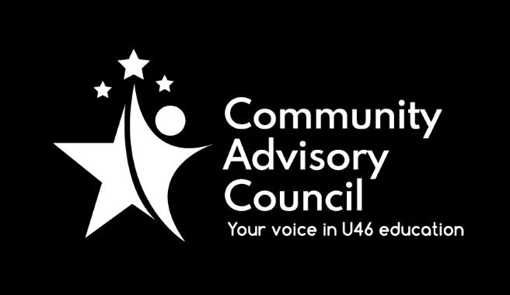

Community Advisory Council

Executive Committee Meeting Minutes
February 17, 2022
- Call to order: Meeting was called to order at 7:00 pm. Meeting was held via Zoom and attended by Chanda Schwartz, Tracy Kelly, Ginger Kurtz, Avita Odoom, Karla Jimenez
- Approval of minutes from January 20, 2022 meeting (with amendment) Motion to approve by Michael Johnson, second by Avita Odoom, all approved
- Public Comment: None
- Administrative Update: Administrative update provided by Karla Jimenez. District is promoting Kindergarten registration, which coincides with Dual Language registration. No registration fees for 2022-2023 school year. The timeline on the district’s Facilities update has been updated since last meeting. The MyStop App can now be used by high school and middle school students and families, with elementary to be added in March. Covid booster clinics are ongoing and will be added for students in the near future.
- CAC General Meetings Discussion-March Meeting: Presentation will be an update on Pathways.
- Committee Updates: Chanda Schwartz of the Specialized Student Services stated that. SSS presentation on February 8, “No Such Thing as a New Normal – Guide to Navigating Mental Health for Families” was well attended, with lots of parental engagement. The presentation will be made available on the district website in the near future. Their next presentation will be held March 8 “Twice Exceptional: How to Identify and Meet the Needs of Your Twice Exception Child” Registration required, link available on district website. Michael Johnson of Instructional Initiatives stated their next meeting will be an update on Full Day Kindergarten, date yet to be determined.
- Strategic Discussion – CAC Membership Outreach: Committee still receiving feedback from members; however committee member attendance must be reviewed and some schools may be decertified due to low/no attendance.
- Other Business: Instructional Council is looking for volunteer to sit on the committee, as Sarah Siddiqui cannot due to schedule conflicts. Discussion on committee chair positions, need to create Nominating Ad-Hoc committee in March, voting on new Executive board to be held in May.
- Adjournment: Motion to adjourn made by Avita Odoom, second by Michael Johnson. All approved and the meeting adjourned at 8:01 pm.

Minutes submitted by: Tracy Kelly on March 16, 2022
Minutes approved by:

