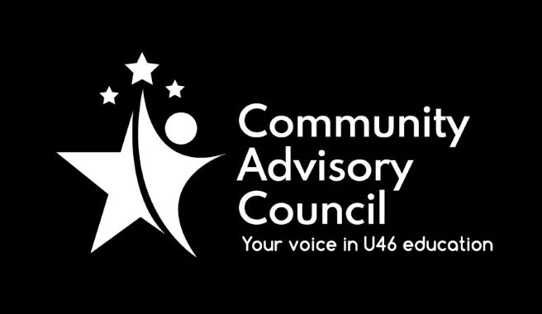

Community Advisory Council

Executive Committee Meeting Minutes
March 17, 2022
- Call to order: Meeting was called to order at 7:00 pm. Meeting was held via Zoom and attended by Chanda Schwartz, Tracy Kelly, Ginger Kurtz, Matt Hovey and Michael Johnson
- Approval of minutes from Feb 17, 2022 meeting (with amendment) Motion to approve by Michael Johnson, second by Chanda Schwartz, all approved
- Public Comment: None
- Administrative Update: There was no update
- CAC General Meetings Discussion-April Meeting: Presentation on Equity, Diversion and Inclusion by Dr. Theresa Lance
- Committee Updates: Ginger Kurtz of the Specialized Student Services stated that. SSS presentation on March 8 on Twice Exception Child was attended by about 50 people and that it is the last presentation for this school year. The presentation will be made available on the district website in the near future. Their next meeting will be held on April 12 to brainstorm ideas for presentations for the next school year. Michael Johnson of Instructional Initiatives stated March meeting cancelled due to technical difficulties, to be rescheduled in April. Matt Hovey stated that FACE committee has completed business for this school year and looking forward to returning to in person meetings in the near future.
- Nominating Committee: Michael Johnson will chair Ad-Hoc nominating Committee for the purpose of electing new officers for CAC Executive Board.
- Strategic Discussion – CAC Membership Outreach: Discussion of committee rep attendance and whether to certify/decertify schools. Decided against decertifying schools with low or no attendance. Motion to bring resolution that there will be no school decertification process made by Matt Hovey and seconded by Michael Johnson.
- Other Business: Committee will continue it’s focus on garnering new interest and building CAC involvement in schools and community.
- Adjournment: Motion to adjourn made by Matt Hovey, second by Michael Johnson. All approved and the meeting adjourned at 8:20 pm.

Minutes submitted by: Tracy Kelly on April 19, 2022
Minutes approved by:

