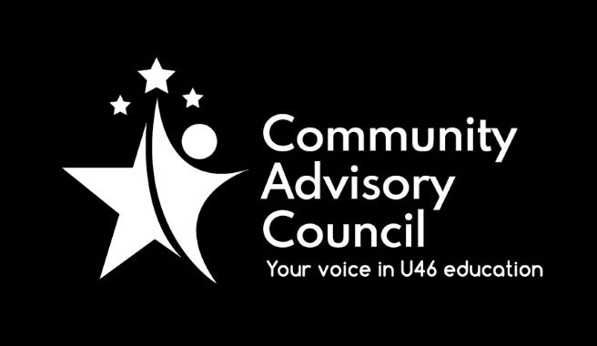

Community Advisory Council

Executive Committee Meeting Minutes
April 21, 2022
- Call to order: Meeting was called to order at 7:01 pm. Meeting was held via Zoom and attended by Chanda Schwartz, Ginger Kurtz, Matt Hovey, Sarah Siddiqui, Avita Odoom, and Michael Johnson.
- Approval of minutes from March 17, 2022 meeting Motion to approve by Matt Hovey, second by Ginger Kurtz, all approved
- Public Comment: None
- Administrative Update: First Unite U46 session on Wednesday, April 27th. The Administration would appreciate spreading the word as much as possible. A Job Fair will be held at South Elgin HS on Saturday April 30th. There were 20 scholarship recipients this year. HS graduations will be live streamed.
- CAC General Meetings Discussion: The next year CAC dates were approved, first and seconded by Sarah Siddiqui, and Matt Hovey. The default position will be to have all in person meetings. The first exec meeting of the new year will be August 11th, although this date is tentative.
- Committee Updates: SSS report will be presented. The report was shown to the executive committee and approved by motion from Matt Hovey and Michael Johnson. No other committee will present a report for this year.
- Strategic Discussion – CAC Membership Outreach: The executive committee would like to ensure that a CAC mention is available to principals to send out during back-to-school announcements/newsletters. The possibility of having CAC representation at some back-to-school events may also be explored.
- Adjournment: Motion to adjourn made by Ginger Kurtz, second by Chanda Schwartz. All approved and the meeting adjourned at 7:56 pm.

Minutes submitted by:
Minutes approved by:

