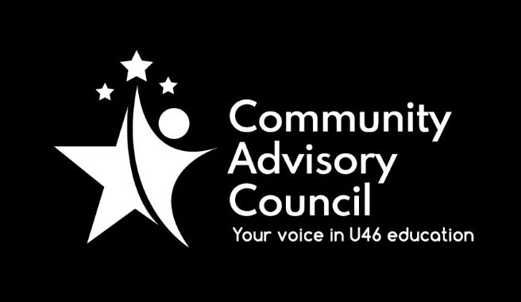

Community Advisory Council

Executive Committee Meeting Minutes
January 20, 2022
- Call to order: Meeting was called to order at 7:00 pm. Meeting was held via Zoom and attended by Chanda Schwartz, Tracy Kelly, Matt Hovey, Sarah Siddiqui, Avita Odoom, Karla Jimenez and guests
- Approval of minutes from October 21, 2021 meeting (amended to correct spelling of Brian Lindstrom). Motion to approve by Matt Hovey, second by Sarah Siddiqui, all approved (with amendments). Motion to approve November 18, 2021 minutes by Ginger Kurtz, second by Avita Odoom, all approved.
- Public Comment: None
- Administrative Update: Administrative update provided by Karla Jimenez. New guidelines on Covid protocols went out on January 20. The U-46 Educational Foundation launched a scholarship platform where all scholarships will be available for students to see. Kindergarten registration is coming up soon and will run concurrently with Dual Language registration. The 5 Essentials Survey is now open, the push to complete the survey will come up the week of February 14. Several district schools have partnered with Proximity Learning, so families have the option of remote learning if student is quarantined.
- CAC General Meetings Discussion-February Meeting: There will be Dual Language update at February meeting.
- Committee Updates: Matt Hovey of FACE stated that next meeting will be held on January 27, discussing the Six Components of Family Engagement. Sarah Siddiqui of the Specialized Student Services stated that. SSS will hold their next presentation on February 8. The presentation is “No Such Thing as a New Normal – Guide to Navigating Mental Health for Families”. It is the second presentation in their 2-part series, registration is open and required, more information can be found on district website. More information to follow next month on March presentation. Chanda Schwartz advised, in Michael Johnson’s absence, that Instructional Initiatives had great turnout at January meeting for their discussion on Equity & Discipline.
- Strategic Discussion – CAC Membership Outreach: Committee has received feedback from CAC member stating that emails are helpful in keeping members updated. Committee discussed ways to bring ideas to the board and making recommendations to the board. Discussed that CAC has somewhat shied away from recommending ideas and becoming more of an informational board. How does committee return to the original intent of the CAC? Discussed having Board of Education members attend meetings?
- Other Business: Karla Jimenez discussed bringing back the Student Culture & Safety Committee, as it is an important topic and making a call to committee for someone to chair the committee. Committee is adding discussion of Facilities Committee to February agenda. Karla also mentioned that she is looking for interested members of Executive committee to join Instructional Council Committee, headed by Celia Banks. This committee meets once a month during the day and requires commitment of 2-3 years. Sarah Siddiqui expressed interest in a role on the committee.
- Adjournment: Motion to adjourn made by Matt Hovey, second by Sarah Siddiqui. All approved and the meeting adjourned at 8:15 pm.

Minutes submitted by: Tracy Kelly on February 16, 2022
Minutes approved by:

