***WEDNESDAY***

***September 27, 2023***

***Morning Announcements***

* Today is Mac & Cheese w/choice of meat, beans and fresh toppings.
* Hispanic Heritage Month Facts – Hispanic Heritage Month began as a week-long celebration back in 1968. Over time, it was extended to a month-long celebration in order to properly recognize the significant contributions that Hispanic and Latinos have made in the United States. This year’s theme is “We are all, we are one”, which strengthens the diversity in the Hispanic community and the power that comes from being a united community.
* Just a Reminder of this week's Homecoming Dress-Up Days:
  + Wednesday-Country vs Country Club
  + Thursday-Barbie, Ken, and Friends Career Day
  + Friday-Class T-Shirt/Color Day--Seniors (Pink), Juniors (Purple), Sophomores (White), Freshmen (Red)
* Blue Crew is awarding one student every day this week with a school spirit award. Students (and staff) check your email and fill out the Google Form with your nomination for most spirited Country vs. Country Club. The student with the most nominations will win a prize.
* Attention all girls basketball players ~ There will be an informational meeting on 9/28 after school, from 3:10-3:20 in C27 to discuss open gyms and workouts until season.  There will also be workouts for any girl interested after the meeting on the track outside after the meeting.  Please see Coach Knapp with any questions.
* Homecoming Dance from 7-10pm. Doors open at 6:30pm and there will be no entrance after 8pm.  Tickets are $15 in advance or $20 at the door.  Tickets are currently on sale online at [u46.booktix.net](http://u46.booktix.net/) through Friday (9/29). There will be a limited number of tickets sold for admission to the dance so please purchase your tickets as soon as you can. Tickets will also be sold during lunch periods at the Treasurer's Office Thursday-Friday (cash or check only).  Guest forms are available in the Main Office and Office of Culture and Climate.  No student on LOP will be allowed entrance to the dance.
* After School Homework Help ~ It is a great feeling to be acing your grades. You can get help after school in the library Mondays through Thursdays from 3-4pm. The 9th Period Royal Academic HUB has tutors to help answer questions; it is also a quiet place to do your work alone. With this extra effort, you can learn more and finish ALL your assignments.
* Thank you to all the classes who competed in this year’s 2023 Homecoming Door Decorating Competition. The winners are as follows:

3rd Place: (Tie)

Mrs. Thompson Business Classes

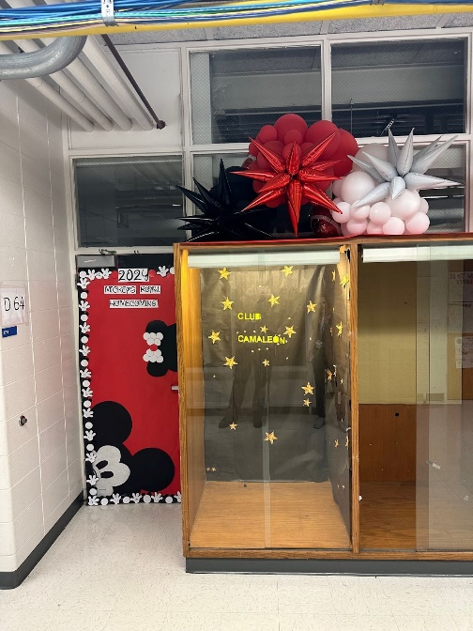

Mrs. Ayala 8th Hour 2D Art 2

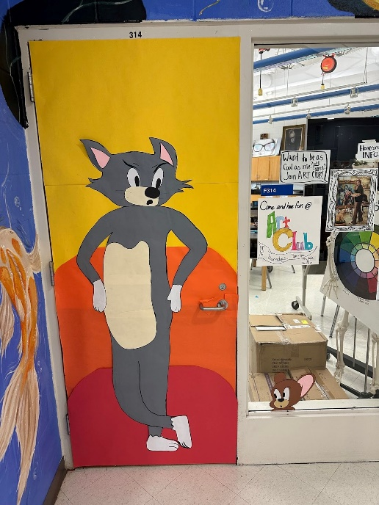

2nd Place:

Ms. Ramirez 1st Period History

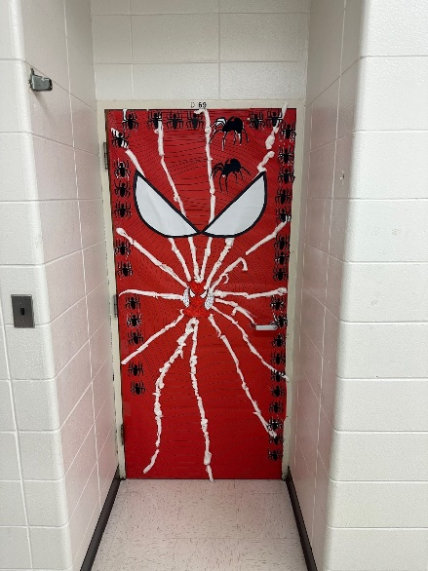

1st Place:

Mrs. Miquelon, Mrs. Watts, and Ms. Otto VPAA Art 7/8th Hour

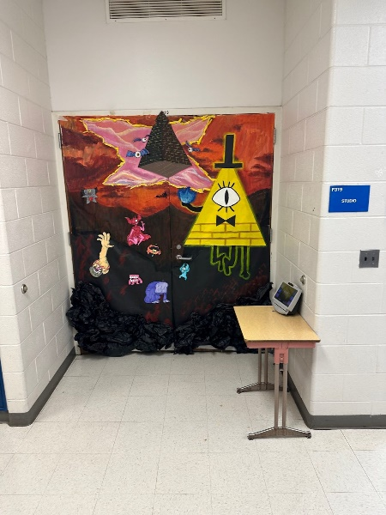

***Royal Congratulations***

**And Remember Royals,**

**LIVE, LOVE LARKIN!**